Research Handbook for Faculty

Compiled by Dr. Christy Tangney, Associate Dean of Research, College of Health Sciences, [ctangney@rush.edu](mailto:ctangney@rush.edu)

For all faculty, a resource for investigators based on contributions from numerous CHS faculty, Karl Oder, Tom Champagne, Allecia Harley, Jennifer Garcia, Katie Amsden, Tony DeMarco, Mary Jane Welch, Stephanie Guzik, Colleen Sowinski, Poorna Nagarajan, Susan Chubinskaya

Sept 2017

Contents

I. AN OVERVIEW OF RUSH RESEARCH RESOURCES 6

A. Office of the Vice Provost for Research 6

B. Office of Research Affairs 6

Rush University Cancer Clinical Trials Office - 7

1. Biological Safety Program 7

2. DURC and Biohazard Committees 8

3. Radiation Safety Program 8

4. Laser Safety Program 8

5. Division of Sponsored Programs Administration 8

6. Division of Institutional Animal Care & Use – Comparative Research Center 8

7. Technologies Supporting Research 9

C. Research Core Facilities 9

1. Services 10

Rush Bio Specimen Freezer Facility 14

Neighboring University Core Research Facilities 14

D. Responsible Conduct of Research 14

E. The Rush Research Mentoring Program 14

II. Identifying a Funding Opportunity 15

Whom can I contact for a Philanthropy research search 17

III. Grant Preparation 17

A. Quick Reference Institutional Information 17

B. Identification and assurance numbers 17

C. Rush officials signing for government sponsored proposals 17

Who to contact for help? 20

Forms and Templates for Federal Grants 20

D. Forms and templates (these are links!) 20

eRA account request form 20

E. Letter of intent template 20

NIH biosketch 20

F. NIH other support 20

G. Prefilled PHS398 face page 20

H. Statement of work template 20

1. 21

I. Budget templates 21

The Budget… 21

Facilities EXAMPLES 23

The content of the science that you propose in your grant 28

IV. Training to use the Rush Research Portal (RRP) and conduct research at Rush 29

1. For CITI Training 29

Research Portal Training 29

Onboarding 29

2. How do I get access to the Rush Research Portal (RRP)? 29

B. Research Portal Training 31

1. How to Set up your Master Project and its Components: 31

C. Grant SmartForms in Rush Research Portal 34

V. Does my research require IRB review? 42

A. 42

B. Research with de-identified human data or specimens or not human subjects research”(NHSR) 42

C. Master Document 42

D. Coverage Analysis 42

1. If have questions about coverage analysis; who should I contact? 42

2. 43

3. IRB or Institutional Review Boards 43

4. . 43

E. If I have questions about the IRB application; whom should I contact? 43

F. What does it mean when my study is in pre-submission in the RRP? 43

G. My study will involve an investigational device (e.g., IDE). Who do I call with questions? 43

H. 43

VI. Developing and submitting a grant application is a team effort. 45

VII. Who do I need to contact if it is a Contract? Subcontract? 46

VIII. 46

IX. When a substantial portion of the work in a Rush Award is being done by others, you need an Outgoing SubAward request and these same individuals can be contacted. 46

X. What if I plan to use someone else’s data? 47

A. Intellectual Property Documents 47

B. 47

XI. What happens if the award is *being applied* for or coming from a foundation? 47

XII. NOW YOU HAVE THE GRANT/CONTRACT… 49

XIII. Just-In-Time (JIT) via eRA Commons 49

A. Post-submission of philanthropic grant proposal: 50

B. Purchasing: 51

C. Step 1: Submit and Obtain Approved Requisition 51

D. Step 2: Issue Purchase Order 52

E. Step 2B: When the purchase is a computer…. 52

F. Step 2C: When your purchase is for an item that exceeds $5000 52

G. Step 3: Vendor submits invoice 52

H. Check requests 53

I. Expense reimbursements 54

J. How Can I Order Supplies through Link? 55

XIV. 57

XV. 57

XVI. Once your manager has completed the New Requester form, follow the steps below: 57

A. How can I order supplies now that I am a requester? 58

B. ` 58

1. On Link homepage under Requisitions & POs select, Create a Requisition 58

2. Select the Basic Tab if you are not already defaulted to the tab, and follow the instructions below: 58

How to Place an Order with a Special/Service Vendor? 60

1. On Link homepage under Requisitions & POs select, Create a Requisition 60

2. Select the Basic Tab if you are not already defaulted to the tab, and follow the instructions below: 60

C. How Can I View the Status of My Order? 63

Contacts in Purchasing for Questions Relating to an Order: 63

D. How do I check on the progress of my warehouse orders? 64

E. How do I find out what budget categories are and are not allowable on my grant? 64

F. 64

XVII. How to Purchase a Computer/Laptop 65

XVIII. How to purchase a computer/laptop that is not on the pre-approved list 65

A. How do I access and read the accounting reports for my fund (awarded grant)? 65

B. If I ship or receive hazardous materials do I need training? 66

XIX. Hiring Research Personnel 66

How do I create a position for a research staff member on a newly awarded grant? 66

A. 66

B. Who can answer questions about how to configure a position (e.g., job category, status, etc.)? 66

C. If a staff member leaves my project, what do I have to do? 66

D. 67

E. I need a research assistant, but don’t have money to pay them. Any suggestions? 67

F. How do I “on-board” Departmental or research volunteer? 67

XX. 67

XXI. 67

XXII. 67

XXIII. 67

A. Letter of Introduction for Departmental Volunteers 68

B. Volunteer Name: _____________________________________________________ 68

C. Start Date: _____________________________________________________ 69

D. 69

E. Expected End Date: _____________________________________________________ 69

F. 69

G. Department: _____________________________________________________ 69

H. 69

I. Assignment: _____________________________________________________ 69

J. 69

K. How can I pay a consultant on my grant? How do I get paid as a consultant? 69

I need a statistician for my grant. 71

XXIV. I have found that requests for Epic data are a great avenue through this group. Contact me for further information. 73

XXV. How do I get an EPIC account? 73

XXVI. I am starting to set up a master project for a sponsored study. It asks for a NCT number. What is this and where do I find it? 73

XXVII. I have a PI-initiated study. Do I need a NCT number? 73

XXVIII. If I have questions when I register my study with clinicaltrials.gov, who can I call? 73

XXIX. 74

a) 74

B. Who can approve my research recruitment/advertising materials (newspaper, television, radio, bulletin boards, posters and flyers)? 74

XXX. 76

XXXI. What are the institutional policies regarding payments to human subjects? 76

A. 77

XXXII. What can I do to purchase parking tickets for research participants? 78

XXXIII. 78

XXXIV. What if I have to invoice another principal investigator in order to get paid? 78

XXXV. 79

XXXVI. Subject Eligibility Checklist: Documentation 80

XXXVII. Good Eligibility Documentation Practices 80

A. Sample Study Subject Inclusion/Exclusion Checklist 81

B. 82

C. Who can translate my Informed Consent document? 82

D. Documenting Informed Consent for Research: Dos and Don’ts 82

1. Consent Process Checklist for Research 84

2. Source Document Information 85

3. 86

XXXVIII. Who is the Office of Research Compliance? 87

A. 88

1. Delegation of Responsibility 88

B. Sample Delegation Log 90

C. Master Regulatory File Essential Documents 91

1. Guidelines for the Study Regulatory File 91

2. Guidelines for the Research Subject File 93

XXXIX. REDCap for DATA Collection 95

A. I need a Professional Graphic Illustrator. Any suggestions? 96

B. I need to have a poster made; what are my options? 97

XL. 98

XLI. What about Authorship? What are Rush’s policies or guidelines on this… 98

XLII. 99

XLIII. Additional Forms 99

Memo for Faculty to Donate Monies 100

A. Independent Contractor Invoice Template 101

B. Internal Request to Use UIC – CCTS Services 102

# AN OVERVIEW OF RUSH RESEARCH RESOURCES

**This SECTION includes information for prospective research participants, sponsors, and investigators - including hyperlinks to many online resources**

## [Office of the Vice Provost for Research](http://www.rushu.rush.edu/servlet/Satellite?c=RushUnivLevel1Page&cid=1229277694983&pagename=ResearchAtRush%2FRushUnivLevel1Page%2FLevel_1_Audience_Portal_Home_Page)

Rush is committed to fostering centers of excellence that combine clinical, basic and population science to study areas of importance to the community. A comprehensive Strategic Plan for Research and several programs have been created to support and encourage Rush investigators involved in more than 1,600 research studies - including clinical trials of new medical and surgical therapies. The office is under the direction of [Joshua J. Jacobs, MD](mailto:Joshua.Jacobs@rushortho.com), vice-president, Vice Provost for Research, and Institutional Responsible Official. The Office of the Associate Provost helps establish and support the mission of Research at Rush which is dedicated to the pursuit of outstanding biomedical research to advance knowledge and optimize patient care.

## [Office of Research Affairs](https://www.rushu.rush.edu/research/office-research-affairs)

The Office of Research Affairs (ORA) exists to partner with faculty and staff as they seek funding, propose clinical studies, establish collaborations, steward funds, submit grants, negotiate industry contracts, and secure patents and licensing agreements. The ORA is headed by Rush’s Chief Research Administrator, [Thomas J. Champagne, Jr., MBA](mailto:tom_champagne@rush.edu) and has organizational reporting responsibilities to the Office of the Provost (Associate Provost for Research), and the Office of Medical Affairs (Vice President & Principal Business Officer) at Rush.

The ORA is comprised of six distinct service divisions - intent on delivering high quality service, support, and counsel to the Rush research enterprise, faculty, staff, and students. The Divisions of the ORA, along with their respective leaders, are:

[**Clinical Research Administration**](https://www.rushu.rush.edu/research/office-research-affairs/clinical-research-administration) [Allecia A. Harley, MPH](mailto:allecia_harley@rush.edu)

[**Innovation & Technology Transfer**](https://www.rushu.rush.edu/research/office-research-affairs/innovation-and-technology-transfer) [Jay Vijayan, Ph.D., MBA](mailto:SHRIJAY_VIJAYAN@rush.edu)

[**Institutional Animal Care and Use**](https://www.rushu.rush.edu/research/office-research-affairs/institutional-animal-care-and-use) [Jeffrey P. Oswald, DVM](mailto:Jeffrey_P_Oswald@rush.edu)

[**Research Regulatory Operations**](https://www.rushu.rush.edu/research/office-research-affairs/research-regulatory-operations) Crista Brawley, Ph.D., CCRP

[**Sponsored Programs Administration**](https://www.rushu.rush.edu/research/office-research-affairs/sponsored-programs-administration) [Jennifer L. Garcia, B.S.](mailto:jennifer_garcia@rush.edu)

[**Technologies Supporting Research**](https://www.rushu.rush.edu/research/office-research-affairs/technologies-supporting-research) [Karl L. Oder, M.S., MSRA](mailto:Karl_Oder@rush.edu)

Specific details for these Divisions follow below.

**1.** [Division of Clinical Research Administration](https://www.rushu.rush.edu/research/office-research-affairs/clinical-research-administration)

The clinical research administration division (CRAD) within the Office of Research Affairs facilitates the financial and operational aspects of clinical research across Rush. In addition, it partners and supports the [cancer clinical trials office](https://www.rushu.rush.edu/research/departmental-research/internal-medicine-research/cancer-center-clinical-trials), which focuses on oncology clinical research.

Rush University Cancer Clinical Trials Office -A Division of the Cancer Center that has strong relationships with Clinical Research Administration is the Rush University Cancer Clinical Trials Office, led by Crista Brawley, PhD. It encompasses functions similar to the Clinical Research Core, but on a larger scale and is focused on adult hematology/oncology clinical research only across the institution. It consists of a regulatory team, a research nurse team, a research coordinator team, and an ancillary services team. Together, under the direction of the Director, they currently conduct about 200 trials across the Cancer Center. Their focus is on pharmaceutically sponsored trials phase I through IV.

**2.** [Division of Innovation & Technology Transfer](https://www.rushu.rush.edu/research/office-research-affairs/innovation-and-technology-transfer)

The Division of Innovation and Technology Transfer (I&TT is responsible for managing the intellectual property assets generated by research and educational activities at Rush. The I&TT division seeks to guide technologies through the various stages of the commercialization process by providing services that include evaluation, protection, marketing, and licensing of intellectual property. The I&TT division protects faculty interests while advancing discoveries toward commercial development.

3. Division of Research Regulatory Operations (RRO)

The ORA supports a Division of Research Regulatory Operations (RRO) that has primary responsibility for stewarding Rush’s regulatory responsibilities as imposed by sponsors, other institutions, as well as community, local, and Federal government agencies. The Division has responsibility to oversee the administrative effectiveness and responsiveness of regulatory committees at Rush including, among others, the IRB, IACUC, DURC, Biosafety, and data safety monitoring activities. Monitoring general laboratory safety is also within the prevue of the RRO division. Rush’s Institutional Biosafety Officer is a member of the RRO division staff. Additional details of the key RRO regulatory groups can be found below, throughout this document, and at the hyperlink above.

### Biological Safety Program

Since 1997**,** Rush University Medical Centerhasoperated an Institutional Biosafety Committee (IBC) to review all research activities involving recombinant or synthetic nucleic acids as required by the *NIH Guidelines* *for Research Involving Recombinant or Synthetic Nucleic Acid Molecules* (rev. 2016) and by university policy RA-IBC-001. This 11-member committee chaired by Amarjit Virdi, Ph.D. has cross-representation from the Institutional Animal Care and Use Committee (IACUC) and from the division of Environmental Health and Safety (EHS). IBC business is conducted in standing monthly convened meetings. The Biological Safety Officer (BSO), Ed R. Blazek, Ph.D., SM (NRCM) pre-reviews applications to assist the investigator prior to official review by the full committee, reviews literature relevant to applications in service to the IBC, and schedules the agenda of the IBC

### DURC and Biohazard Committees

Rush University Medical Center is in compliance with the *United States Governmental Policy for Institutional Oversight of Life Sciences Dual Use Research of Concern.* This policy governs all research performed with any quantity of 14 specific pathogens and one toxin, requiring the *institutional* review of such research to determine whether a risk mitigation plan is needed to minimize the chance that the research will be misapplied. If the research meets these criteria, the risk mitigation plan must be approved and enforced. Under its approved institutional policy RA-DURCBHZD-001, Rush has established the required Institutional Review Entity (IRE) called the DURC Committee, and has named an Institutional Contact for Dual-Use Research (ICDUR, Mary Jane Welch, DNP), who also chairs the committee. The DURC Committee will convene quarterly to review new potential DURC research and do annual continuing review of previously-approved projects. The DURC Committee has determined that no current research at Rush meets the DURC criteria to require approval of a risk mitigation plan.

### Radiation Safety Program

Rush University Medical Center has a Radiation Safety Program under the direction of Radiation Safety Officer (RSO) Manjeet Hansra. A broad-based Radiation Safety Committee (RSC), as required by the State of Illinois, is chaired by Mark Supanich, Ph.D. All routine clinical and research laboratory aspects of ionizing radiation use, such as dose monitoring, radiation protection, nuclear medicine hygiene, and radioactive waste disposal, are managed by the RSO under oversight by the RSC.

### Laser Safety Program

Rush University Medical Center has a Laser Safety Program under the direction of Clinical Engineering Services, Gene A. Ward, Director and Randall E. Johnson, Interim Laser Safety Officer (LSO). The purpose of the program is provide clinical staff, researchers, students, patients, and visitors with a safe laser use environment by managing the selection, use, and maintenance of lasers and laser-containing systems at Rush University Medical Center and Rush University Medical Group. This program implements guidelines to ensure that no laser radiation in excess of the maximum permissible exposure (MPE) limit reaches the eye or skin of clinical staff, students, patients, and visitors.

### [Division of Sponsored Programs Administration](https://www.rushu.rush.edu/research/office-research-affairs/sponsored-programs-administration)

Sponsored Programs Administration (SPA) within the Office of Research Affairs (ORA), led by [Jennifer Garcia](mailto:Jennifer_Garcia@rush.edu), provides assistance to faculty and staff in obtaining and managing sponsored awards that support research activities. SPA is charged with reviewing and approving proposals submitted to all sponsors, for interpreting, negotiating, and accepting grants and contracts for sponsored programs funded by federal and state agencies, foundations and other public agencies, and providing guidance to assure proper stewardship of funds that are received. In addition, SPA prepares and negotiates sub-awards for collaborative research.

### [Division of Institutional Animal Care & Use – Comparative Research Center](https://www.rushu.rush.edu/research/office-research-affairs/institutional-animal-care-and-use)

Rush is committed to the judicious and humane care and use of animals in teaching, research and testing. The use of animals at Rush is a privilege granted through the Institutional Animal Care and Use Committee (IACUC), with moral, scientific and legal obligations for humane care and treatment of the animals.

The [Comparative Research Center (CRC)](http://iris.rush.edu/crc/index.html) is located in state-of-the art facilities in the RUMC, Cohn Building and occupies approximately 23,300 gross square feet. The Comparative Research Center is responsible for implementing the Rush Animal Care and Use Program and managing animal care facilities in accordance with the Guide. The Center's functions include procurement, care and maintenance of all animals used in research, teaching and testing, and the provision of professional advice to research and teaching staff.

### [Technologies Supporting Research](https://www.rushu.rush.edu/research/office-research-affairs/technologies-supporting-research)

The ORA works closely with the Office of Information Services at Rush to support key research administration technologies including the Rush Research Portal, Faculty Profiles, Inter- and Intranets for Research, LINK, COI databases, GRANITE, e-IRB capabilities, interfaces with sponsor databases, and other network and infrastructure-related needs of faculty and staff. A clinical trials management system (CTMS) is currently under development and is now available in 2017.

The [Rush Research Portal (RRP)](https://www.rush.edu/researchportal) is a key methodology to manage many aspects of the clinical research and sponsored programs submission process. All new clinical research studies are submitted electronically through the RRP. IRB studies that were active prior to September 17, 2007 (legacy studies) have been uploaded into the system.

Coverage Analysis, Grants and Contracts are also created and submitted through the RRP. This allows an efficient process linking the IRB study, Coverage Analysis, Grants and Contracts in one central location. Finally, a module that will facilitate submission and administrative oversight of clinical studies conducted at Rush that use a central IRB is being built. After

## [Research Core Facilities](https://www.rushu.rush.edu/research/office-associate-provost-research/core-research-facilities?c=RushUnivLevel2Page&cid=1260198526365&pagename=Rush/RushUnivLevel2Page/Level_2_Audience_Portal_Page&rendermode=preview)

All the scientific cores have pricing structures that are advantageous for Rush investigators and will therefore allow greater productivity per grant expenditure than comparable external facilities operated by neighboring universities or commercial laboratories. With rare exceptions, investigators can receive training to operate these facilities independently, thereby reducing the labor charges associated with larger projects.

**1**. MicroCT/Histology Core (MCTHC).

MicroCT is a non-destructive, x-ray based means of constructing three-dimensional images of objects with natural or contrast-enhanced radio-opacity. The laboratory has been used by intramural and extramural researchers for *ex vivo* three-dimensional imaging of bone, cartilage, nerve, vascularity, and various biomaterials by PIs from Rush and several universities across the U.S. There are two scanners in the lab. The MicroCT/Histology Core is facilitated by Rick Sumner, Ph.D., chair of the Department of Anatomy and Cell Biology.

**2.** Flow Cytometry Core (FCC).

***Instrumentation:*** The Rush University Medical Center flow cytometry core facility currently operates four Becton-Dickinson instruments: one dual-laser FACSCalibur, one three-laser FACSCanto II, one three-laser BD-LSR II analyzer and one four-laser BD LSRFortessa. The FACSCalibur flow cytometer is an end user-operated instrument with two lasers, permitting measurement of four fluorescent and two light-scatter parameters. Trained users prepare and acquire/analyze their own samples using a Macintosh G4 computer and either CellQuestTM or FlowJo software. The facility staff will train investigators in the use of data analysis software programs for the purpose of data reanalysis or graphics production.

### Services

* Immunophenotyping
* Cell viability/apoptosis
* Intracellular protein staining
* Multiplex assays for detection of cytokine and chemokines
* Cell tracking and proliferation
* Cytotoxicity
* DNA or RNA analyses

The flow cytometry core was established in the Department of Immunology and Microbiology and is under the direction of Alan Landay, Ph.D.

**3.** Rush Proteomics Core (RPC)

The Rush Proteomics Core (RPC) offers a wide range of services for designing, conducting as well as analysis of researches related to proteomics. These services include the identification of proteins including antigens, profiling of serum and plasma proteins, detection of novel serum and tissue biomarkers indicative of diseases, analysis of post-translational modifications, characterization of protein-protein interactions, and identification of molecular pathways involved in health and disease. The RPC supports the research of both junior and senior investigators and assists clinical/translational researchers in conducting laboratory procedures. **RPC services include: (1) consultations on experimental design, methods for conducting the experiments, post-experiment data analysis and** recommendations related to the most appropriate experimental platform for specific research objectives and data interpretation, (2) training for self-service, and (3) performance of procedures as needed. RPC personnel also teach in several graduate-level courses to introduce basic proteomics methodology to students and young investigators. The RPC develops protocols for protein fractionation and provides assay development as needed. Proteins are separated and detected using **one- and two-dimensional gel electrophoresis, Western blot**ting and image acquisition and bioinformatics analysis, and one- and two-dimensional nano-flow HPLC separation. RPC facilitator is Dr. Animesh Barua, Ph.D. and the facility is managed by Seby Edassery M.S, a biotechnology and bioinformatics specialist with over 10 years’ experience in molecular biology, proteomics and data analysis.

**4.** Rush microRNA and Gene Expression Core (RMGEC).

The microRNA and Gene Expression Core facilitates research on the determination of molecular pathogenesis and diagnosis of disease, development of disease-targeted drug and molecular monitoring of treatment efficacy. RMGEC is equipped with the Applied Biosystems HT7900 RT-PCR with a facility of using 384-well plates and has fully robotic automatic loading capability. The facility uses the DataAssist software to analyze the data. The spectrum of support ranges from investigator training in operation and troubleshooting of the apparatus to experimental design/optimization. The RMGEC encourages collaborations with researchers, will provide support to researchers during their grant application and help to enhance their miRNA and gene expression components of the grant proposals.

The RMGEC facilitator is Dr. Animesh Barua, Ph.D. and the facility is managed by Seby Edassery.

**5.** Rush Biomarker Development Core (RBDC)

The Rush University Biomarker Development Core provides a cost-effective and rapid means to evaluate protein biomarkers (such as cytokines, growth factors, and autoantibodies) in any biological specimen and for any size project, including large clinical trials. Examples of biological samples include: serum, plasma, synovial or cerebrospinal fluids, urine, tissue or cell lysates, and conditioned media.  All evaluations can be performed with either absolute or relative quantitation, and will be performed using the Luminex xMAP immunobead platform by highly-experienced experts trained by the Luminex Corporation. This platform permits simultaneous quantification of up to 500 analytes from low microliter volumes of sample. Early disease detection and monitoring of disease progression and treatment response are principal applications. Commercial kits are available for a wide array of potential analytes by multiple partners of the Luminex Corporation. We also offer services for custom assay development for any analyte of interest that may not be currently available through commercial sources.

The director of the RBDC is [Jeffrey A. Borgia](http://www.rushu.rush.edu/servlet/Satellite?ProfileType=Short&c=RushUnivFaculty&cid=1200925132399&pagename=Rush%2FRushUnivFaculty%2FFaculty_Staff_Profile_Detail_Page), Ph.D. and the facility is managed by Cristina Fhied. For questions please contact Cristina Fhied 312-942-2210.

**6.** The Live Animal Imaging Core Facility

The IVIS Lumina II imaging system allows monitoring of cellular activity (quantitative) through bioluminescent or fluorescent reporters in live mice or rats. This system can be utilized to identify tumor development in studies aimed at dissecting the molecular genetics of several types of cancer using mouse or rat models. The imaging system allows the use of a smaller cohort of animals for the research as animals do not need to be sacrificed to ascertain the presence of tumor lesions. The system offers non-invasive longitudinal monitoring of:

1) disease progression (e.g., tumor progression and metastasis)   
2) tumor response and recurrence  
3) cell trafficking and gene expression patterns in living animals  
4) drug metabolism genes due to either the parent molecule or its metabolites.

A potentially greater use of this imaging system is in translational research involving therapeutic trials using animal models for disease. The system comprises a light-tight imaging chamber, a high-sensitivity cooled charge coupled device (CCD) camera, a cooling system for the camera, and proprietary software (Living Image) that controls all of the system components. The IVIS Lumina II allows imaging of up to 5 mice or 2 rats and can also accommodate Petri dishes or micro-titer plates for in vitro imaging. The system is equipped with up to 21 filter sets that can be used to image reporters that emit from green to near-infrared. Access to the system is by login of registered users, the list of which is maintained by Dr. Jitesh Pratap, facilitator.

**7.** IM Research and Drug Discovery Imaging Core

The IM research CORE facilities consist of multiple state-of-the-art imaging, liquid handling, high-throughput, and other analytical equipment. The list of equipment includes High-Content Screening (HCS) Systems, Electron Microscopy (TEM/SEM), Confocal Microscopy, Live-Cell Imaging, and Flow Cytometry. The facilities housing the equipment were entirely renovated in 2013 and early 2014 as part of Dr. Jochen Reiser and Dr. Vineet Gupta’s research laboratories and occupy space on 1st and 7th floor of the Cohn building.

**7A. High-Content Screening (HCS) Systems:** The Core will oversee the operation of a Perkin Elmer’s Opera HCS System, which offers the ultimate in high throughput, speed and resolution – making it the ideal solution for flexible, scalable assay development and robust screening. The Opera system utilizes Acapella high content imaging and analysis software and offers solutions for apoptosis, calcium flux, cell cycle, cell differentiation, cell migration, cell proliferation, cell shape changes, cytoskeletal rearrangement, cytotoxicity, fluorescence in situ hybridization (FISH), lipid droplet analysis, neurite outgrowth, protein expression, receptor activation, RNAi screening, signaling pathway analysis, and transcription factor. The HCS facility also has Perkin Elmer’s JANUS automated workstation - a liquid handling platform that provides real-time and future adaptability for augmented throughput, plate capacity and dynamic volume range. It includes a gripper ‘pick and place’ robotic arm for automatic ‘on the fly’ switching of heads for optimal precision pipetting and performance. JANUS with proprietary Modular Dispense Technology (MDT) NanoHead dispense heads enhance assay miniaturization with 384-tip processing down to 50 nL with C.V.s less than 13%. Also in the HCS facility, a BioTek plate washer is available for washing cells in 96- and 384-well plates.

**7B. Electron Microscopy:** The Core Facility can provide researchers access to a scanning electron microscope with transmission electron microscopy (TEM) capabilities. Services include critical point drying and gold coating of EM samples. The Zeiss Sigma HDVP Electron Microscope is a high definition imaging system capable of producing ultra high resolution images with a resolution of up to 1nm.

**7C. Confocal and Live Cell Microscopy:** The Core will run a Confocal Facility, which is equipped with a Zeiss LSM 700 including two spectral channels and a live cell imaging workstation. The confocal microscope is based on an Axio Observer Z1 motorized inverted microscope with four laser excitation lines from four solid-state diode lasers: 405nm, 488nm, 555nm, and 635nm. The instrument is equipped with a motorized scanning stage with controller. It also has the Zeiss Definite Focus controller for extremely precise focus control during long-term conditions where focus drift is a problem. The Live Cell Imaging microscope is based on a Zeiss Axio Observer D1 inverted microscope and is equipped with an XL-3 Incubator heated stage fitted with a CO2-supplied cover plate. This incubation system enables precise temperature control for the entire instrument and there is a heated stage insert for additional temperature control and CO2 supply at the specimen stage for extended imaging experiments. The instrument uses the Zeiss ZEN Windows-based software, which is user-friendly and logical.

The IM Research CORE facilities are available for use by the RUMC community under the directorship of Antonio Bianco, Ph.D., and the management of Steven Mangos, Ph.D. Access to the facilities is restricted by swipe card access, which is only granted to approved, trained users and staff. A 3 hour training and certification program is required for all users and is available through the IM Research CORE Facilities Coordinator.

**8.** The Biological Safety Level 3 (BSL3) Laboratory

The BSL3 facility (JS 1183) is a negative pressure biohazard containment facility that consists of an anteroom (90 ft2) and laboratory (430 ft2). The facility was totally renovated in 2011 to conform to current Biosafety in Microbiological and Biomedical Laboratories (CDC-NIH, BMBL, 2007) standards for handling RG3 agents, large volume isolation of RG2 agents, as well as new and uncharacterized pathogens when found or genetically modified human pathogens as described in the current NIH OBA current guidelines covering “Recombinant or Synthetic Nucleic Acid Molecules.” The facility would be invaluable as a support laboratory during a bioterrorism event and RUMC’s response. The facility would also be useful for BSL2+ risk level experiments such at the propagation of drug resistant *Mycobacterium* ***tuberculosis****.* The facility is recertified annually to meet current CDC/NIH requirements. The facility is connected to RUMC emergency power and is designed to maintain containment and security during emergency conditions. The BSL-3 Laboratory is available for use by the RUMC community under the directorship of James W. Bremer, Ph.D. Access to the BSL-3 facility is restricted by swipe card access which is only granted to approved, trained staff. A 4-hour training and certification program is available and required of all users.

**9.** Bioinformatics/Biostatistics Core (also under “I need a statistician”)

The Rush Bioinformatics and Biostatistics Core provides advanced biostatistics and bioinformatics resources to a wide range of clinical and population health researchers within the institution to enhance the capabilities of research community at Rush. Core staff can provide statistical analysis on a wide array of studies – data extracted from medical records, and cross-sectional and prospective study of population and clinical studies of health outcomes, and assist with interpreting statistical findings. The Core also provides access to data for researchers from the electronic record and external data sets for linkage and/or analysis.

***Infrastructure****.* Rush has been a national leader in the implementation and integration of systems across the enterprise. The implementation of EPIC, deployed at Rush and Rush Oak Park and across hospital, emergency departments, and outpatient practices, has enabled Rush to achieve the Stage 6 HIMSS designation (achieved by only 5% of health systems) and gives a holistic, integrated view of patient care in one electronic system. The Core is well integrated within both Hospital Information Systems and Clinical Research, and overseen by the Chief Research Information Officer.

The core has built a state-of-the-art computing system, called the research private cloud, in consultation with Rush IS/IT that can support research activities and large databases that can extract electronic medical records of patient data, electronic case report forms from RedCAP data collection system; and biospecimen data. Survey instruments are available on demand to investigators through an on Site implementation of RedCAP.

The research private cloud is composed of an Application Layer (virtualizable; with 72 Cores, 3 TB memory, and 288 threads allocable for use) and a Database layer (Windows 2012 server, SQL Server 2014 enterprise, and 16 TB solid state drive space housing clinical data warehouses). The Cloud hosts an MS SQL database storing research related data and is planned to support virtual environments for researchers, and Hadoop related tools for Big Data analyses. The core also has a dedicated computing cluster for genetic, RNA-seq, and next generation sequencing studies.

***Data sources****.* RUSH maintains an Enterprise Data Warehouse comprised of clinical and administrative data derived from our EPIC Electronic Medical Record and associated clinical IT systems. This single source EDW supports all clinical, research, and operational needs and contains administrative data for greater than 10 years and clinical data back to 2007. RUMC has extensively customized Epic to support quality measurement, decision support, and interactions with our patients through the patient portal implementation. A patient portal application is available to serve as a means of communication with, assessing the health outcomes of, and recruiting patients for participation in studies.

Extracts from the electronic record are curated and housed in the RUSH DISCOVER Repository Data Mart. Derived from the global knowledge management infrastructure of Rush (called Maestro), DISCOVER houses data sets and hosts views from data domains within the Rush enterprise, and protects data through governance processes and the function of an honest broker. Investigators are offered the ability to have a hosted environment for their data, with access to their data through self-service tools (see below). Data are de-identified through the use of an honest broker. Data sources within the RUSH DISCOVER Repository are linked to EPIC data found within the EPIC data warehouse (Clarity); linked datasets include subsets of Clarity with pre and post-processing, as well as relevant Cogito data; Pathology reports with National Language Processing derived interpretations; Radiology Reports with NLP derived interpretations; Microbiology and Laboratory Results; Operative Data; Rush Research Portal data; electronic Case Report Forms obtained from the RedCAP data collection system; and biospecimen data generated from instruments. Data standards in use at RUMC include use of ICD-9/10; CPT coding; SNOMEDCT for clinical concepts; RxNorm for medications; and LOINC coding for clinical laboratory tests. Survey instruments are available on demand to investigators through an on Site implementation of RedCAP, which is maintained by corporate IT. The data model for the research data has been standardized and is a superset of the national Patient-Centered Outcomes Research Network (PCORnet) data model, of which Rush is a participant. Users access data from the RUSH DISCOVER Repository via several options of user interfaces: a self-service portal which can be used to generate count data and demographic information for cohorts; third party software which can identify cohorts on demand through custom tools; and a SQL user interface which can access the research data set through ad hoc queries, views, and stored procedures.

Rush Bio Specimen Freezer Facility

Rush has a centrally-located, 2500-square foot freezer facility. The facility includes a mixture of cryogenic storage units, -80°C mechanical freezers (many with liquid nitrogen backup cooling), -20°C freezers, and refrigeration units for large tissue samples. At present, 59 units are operating, but this number will increase to 114 units and the foot print will expand to 5400 square feet when the second phase of the facility opens in 2014. Units are digitally monitored to give automatic notification of temperature excursions or mechanical failure to both maintenance personnel and to the response tree established by the investigator. Access to the facility is electronically controlled and monitored. This facility provides improved security for specimen collections including an Alzheimer’s brain tissue library, and preserves space in the investigators’ laboratories. The administrative director of this facility is Thomas J. Champagne, Jr.

Neighboring University Core Research Facilities

In addition to the in-house Cores described above,Rush researchers have access to Core facilities at both the University of Chicago and the University of Illinois at Chicago. External Core Director contact information and laboratory locations are available on the respective web sites. The UIC labs are all within walking distance of the Rush campus.

## Responsible Conduct of Research

## [The Rush Research Mentoring Program](https://www.rushu.rush.edu/about/faculty-affairs/rush-mentoring-programs)

The Research Mentoring Program was established July 26, 2006 in order to provide advanced mentoring by funded NIH investigators to an ever-growing population of young faculty. The goal of the program is to prepare junior faculty members at Rush and Stroger Hospital of Cook County to lead funded programs of translational research.

To help junior faculty members become independent researchers, the program relies on two primary mechanisms: good mentoring and resource infrastructure. Mentees are paired with at least one externally funded, experienced, and committed lead mentor who works very closely with the mentee on her/his research project; many mentees also have interdisciplinary mentoring teams. The program’s resources include: statistical analysis, data management, professional grant writing and manuscript editing, graphics consultation, communication skills workshops, monthly “in-house study section” meetings, weekly mentee writing groups, monthly workshops and seminars on a variety of research-related and grant-writing topics, a lending library, and an annual symposium.

Mentees are nominated to the program by their department chairs with the commitment of least 20% protected research time. In addition, mentees are expected to dedicate an additional 20% of their personal time for research. The program has two translational research tracks – clinical and laboratory-based. Each track meets monthly where mentees discuss their research in progress.

The program has enjoyed university-wide popularity and success. In the past nine years combined, mentees (either as principal investigators or as co-investigators/collaborators) have secured or were instrumental in securing close to $72 million in awards, 40% of which are from the NIH. Also, over 1600 manuscripts have been published by mentees to date, since their joining the program. The program has more than 80 active mentors. The program director is Giselle Sandi, Ph.D.

# Identifying a Funding Opportunity

The Office of Research Affairs (specifically the Sponsored Programs) has a number of links that you might search. Please go to…

<https://www.rushu.rush.edu/research/office-research-affairs/sponsored-programs-administration>

I am showing a snapshot of what’s available…

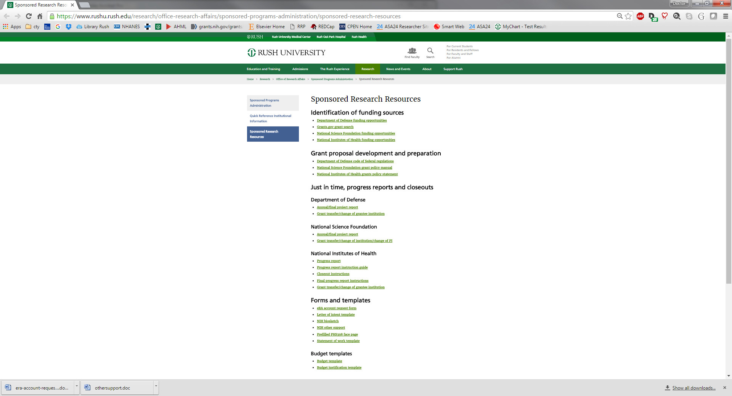

Department of Defense

At several of these links you can set up alerts that can be sent to your email. For example, I get weekly alerts from NIH in my emails. Please see next page….

Grants.gov

National Science Foundation

National Institutes of Health

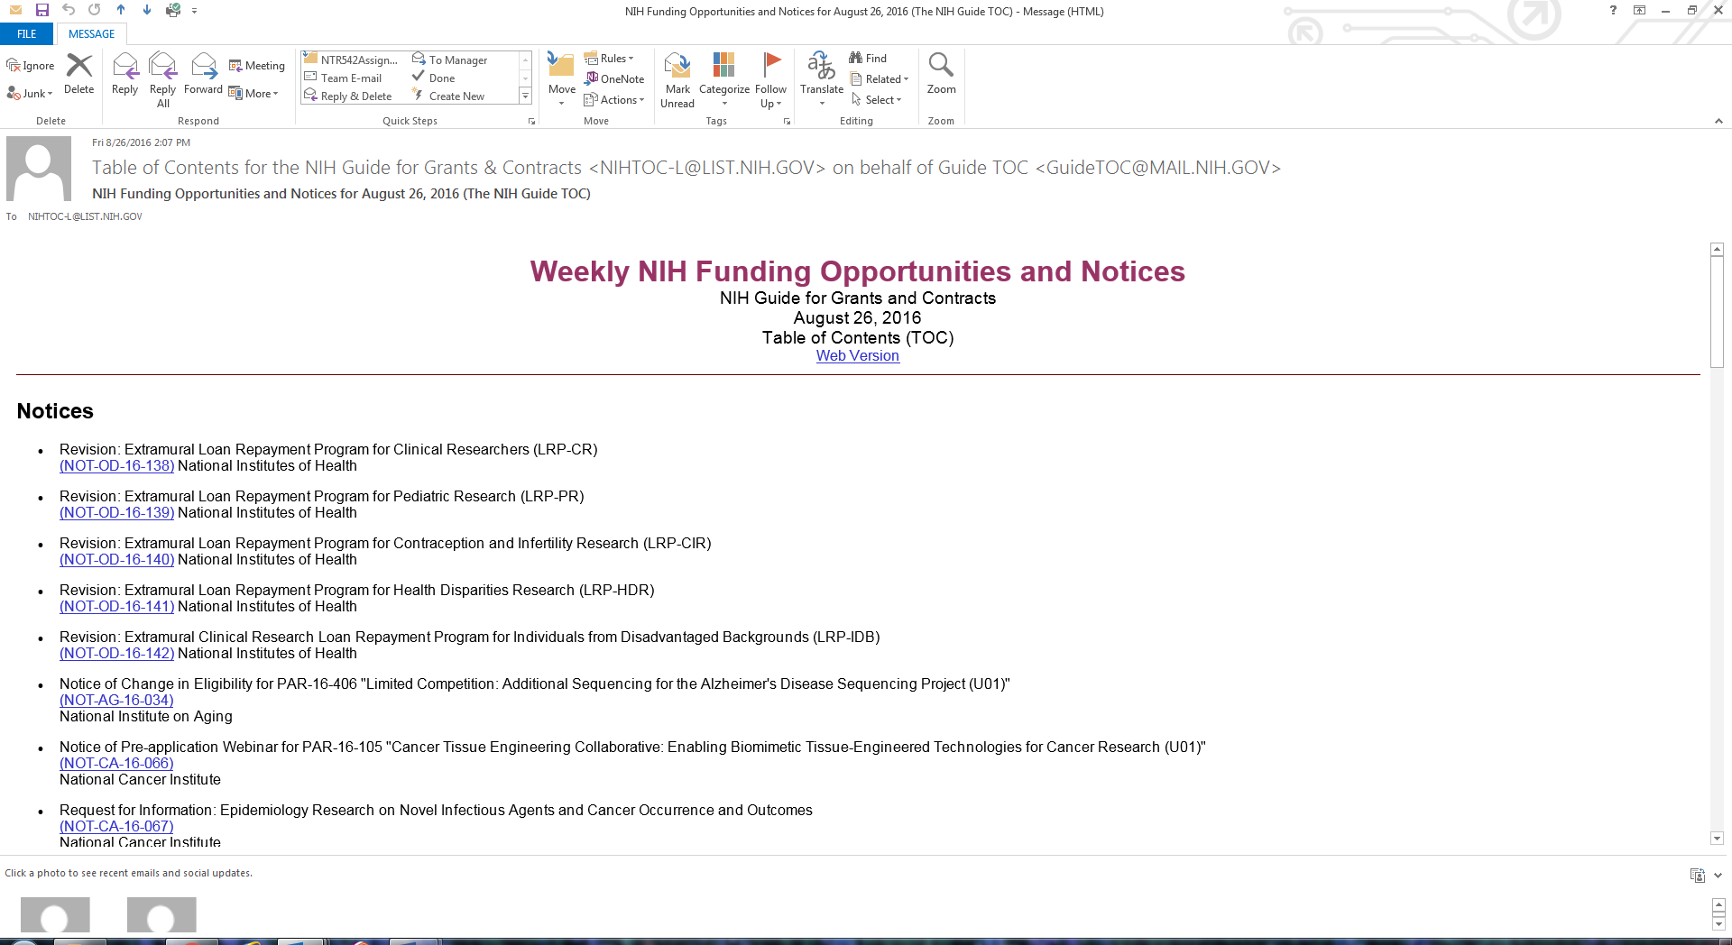

If NIH is the one of the funding sources you might seek… use NIH’s [RePORTER](https://projectreporter.nih.gov/reporter.cfm) [Link to External Site](https://grants.nih.gov/grants/disclaimer.htm), a Report Expenditures and Results tool that allows users to search a repository of NIH-funded research projects and access publications, including other valuable information for researchers in the planning process. Use the [RePORTER search interface](https://projectreporter.nih.gov/reporter.cfm) [Link to External Site](https://grants.nih.gov/grants/disclaimer.htm) to search by term, or use the [Matchmaker interface](https://projectreporter.nih.gov/reporter_matchmaker.cfm) [Link to External Site](https://grants.nih.gov/grants/disclaimer.htm) to input an abstract or other scientific text to find a list of the 100 most similar projects NIH is funding. In this way you can:

Contact the Sponsor or NIH Program Officer to see if your ideas are appealing to the agency

**Plan within Your Organization.** Developing and submitting a grant application is a team effort. Meet with your Office of Sponsored Research (or central grants support office) early in the process.

Whom can I contact for a Philanthropy research search**?**

You can contact Carrie Roche x24611 ([Carolyn_Roche@rush.edu](mailto:Carolyn_Roche@rush.edu)) to schedule a time to come in and access the Foundation Center database.

# Grant Preparation

There is a page with invaluable details that you will need when you start writing your grant. Please check out …

<https://www.rushu.rush.edu/research/office-research-affairs/sponsored-programs-administration/quick-reference-institutional-information>

Such details include ….

## Quick Reference Institutional Information

Tax exempt status: 501(c)3  
Type of organization: not-for-profit corporation  
Legal name: Rush University Medical Center

Rush University Medical Center  
1653 W. Congress Pkwy.  
Chicago, IL 60612-3833

## **Identification and assurance numbers**

Animal welfare assurance number (IACUC): A3120-01  
Commercial and government entity (CAGE) code: 3F752  
Congressional district: IL-007  
Data universal numbering system (DUNS) number: 068610245  
Department of Health and Human Services (HHS) entity identification number: 1362174823A1

## **Rush officials signing for government sponsored proposals**

Grant applications:

[**Jennifer Garcia**](mailto:jennifer_garcia@rush.edu)  
Director, Sponsored Programs Administration  
Phone: (312) 942-3554

Fiscal agent/notice of award:

[**Jane Winger**](mailto:jane_winger@rush.edu)

Assistant Director, Fund Accounting, phone: 312-942-9339



Who to contact for help? For the link to the list login to the Research Portal at

<https://rrp.rush.edu/researchportal/Doc/0/LBMI9DALBO14VFQNT7N6CKK995/ORA_Contact%20List_10Jan2017.pdf>

Forms and Templates for Federal Grants can be found at

<https://www.rushu.rush.edu/research/office-research-affairs/sponsored-programs-administration/sponsored-research-resources>

## Forms and templates (these are links!)

[eRA account request form](https://www.rushu.rush.edu/sites/default/files/Research/era-account-request-form.docx) electronic Registration Account is established so that one can log onto eRA Commons (Commons), an online interface where grant applicants, grantees, and federal staff at NIH and grantor agencies can access and share administrative information relating to research grants.

## [Letter of intent template](https://www.rushu.rush.edu/sites/default/files/Research/Letter%20of%20Intent%20Template.docx)

[NIH biosketch](https://grants.nih.gov/grants/forms/biosketch.htm) this is available here and also on our College portal… This is Version D.*

## [NIH other support](https://grants.nih.gov/grants/funding/phs398/othersupport.doc)

## [Prefilled PHS398 face page](https://www.rushu.rush.edu/sites/default/files/Research/prefilled-phs398-face-page.pdf)

## [Statement of work template](https://www.rushu.rush.edu/sites/default/files/Research/statement-of-work-template.docx)

*Please note: For application due dates of January 25, 2018, and beyond, you will be required to use an updated application forms package (FORMS-E), which includes the new human subject and clinical trial form. This form requests human subject and clinical trials information at the study level using discrete form fields, which is a change from current practice. Contract proposals will also require this information.* [*Learn about the new form here*](https://urldefense.proofpoint.com/v2/url?u=https-3A__grants.nih.gov_policy_clinical-2Dtrials_new-2Dhuman-2Dsubject-2Dclinical-2Dtrial-2Dinfo-2Dform.htm&d=DwMFAg&c=XxU8ngzB_WPJXKyiin_6iQ&r=VoMsOhZNFJn4qLKlo51tXAXYABzUKjwdcEjQwGMKj1Q&m=RtNU_e6XQMbDWJElpRRqTN5LuQGuHhiedN-Yd4a_cW8&s=R9K9J9ILXY8dUOjl4lcxrGF2tTJeTLSQmjoK_py3H0A&e=)*.*

***Second, take a moment to answer these four questions about your current or proposed research:***

*1) Does the study involve human participants?*

*2) Are the participants prospectively assigned to an intervention?*

*3) Is the study designed to evaluate the effect of the intervention on the participants?*

*4) Is the effect that will be evaluated a health-related biomedical or behavioral outcome?*

*If the answer to all four questions is yes, then your proposed research meets* [*the NIH definition of a clinical trial*](https://urldefense.proofpoint.com/v2/url?u=https-3A__grants.nih.gov_grants_guide_notice-2Dfiles_NOT-2DOD-2D15-2D015.html&d=DwMFAg&c=XxU8ngzB_WPJXKyiin_6iQ&r=VoMsOhZNFJn4qLKlo51tXAXYABzUKjwdcEjQwGMKj1Q&m=RtNU_e6XQMbDWJElpRRqTN5LuQGuHhiedN-Yd4a_cW8&s=CvgdDgZalL0ZA0zoOiLXbMIbBgLRu1CqHrj2x3EYRcc&e=)*. Clarified and broadened in 2014, the definition encompasses a wide range of trial types: mechanistic, exploratory/developmental, pilot/feasibility, behavioral, and more. NIH expanded the clinical trial definition in response to widespread calls from diverse stakeholders for improved reporting of research milestones and outcomes, and for assuring maximal transparency.*

***Third, familiarize yourself with NIH policy changes related to enhancing stewardship of clinical trials****.*

*NIH made a number of policy changes to improve the stewardship of clinical trials across the life cycle of the trial. We encourage you to familiarize yourself with all that is changing, including:*

*·        the requirement to apply to an FOA that specifically allows for the submission of clinical trial applications for due dates beginning January 25, 2018.*

*·        Good Clinical Practice training expectations for NIH staff, grantees, and contractors that went into effect January 2017.*

*·        updated peer review criteria that will be included in FOAs for clinical trial applications and solicitations for due dates on/after January 25, 2018.*

*·        new Human Subject Information form requirements for clinical trials that will be included in updated application forms (FORMS-E) for due dates on/after January 25, 2018, and contract solicitations published as of January 25, 2018.*

### 

## Budget templates

* [**Budget template**](https://www.rushu.rush.edu/sites/default/files/Research/BudgetTemplate1.xlsx)
* [**Budget justification template**](https://www.rushu.rush.edu/sites/default/files/Research/Budget%20Justification%20Template.doc)

The Budget…Check with the Office of Sponsored Projects. The Budget Template is downloadable from the Rush website as shown above…

**Budget Worksheet Instructions**

**Please enter data into the YELLOW HIGHLIGHTED sections**

1. Enter the **project name** in A1.

2. Enter the **project start date** in B2 and **project end date** in B3, enter the number of years of the project in B4. The dates will then automatically populate for each year.

3. In G2, enter the **inflation rate** to be used for **personnel.** The worksheet will automatically calculate this % inflation for all personnel in the budget. If any personnel should not have salary inflated, you will need to manually enter the base salary for each subsequent year.

4. Enter the appropriate **indirect cost rate** for this project in cell A74.Current RUMC federally approved indirect cost rates are located at:

<https://www.rushu.rush.edu/research/office-research-affairs/sponsored-programs-administration/sponsored-research-resources>

5. Enter the appropriate **fringe benefits rate** for this project in cells G78/79 M78/79 S78/79; Y78/79; and AE78/79. Current RUMC federally approved fringe benefits rates are located at: www.rushu.rush.edu/researchtoolbox

6. In row 7, enter the **PI**'s name, projected base salary at the time of award and **% effort**. The worksheet will automatically calculate **calendar/person month’s effort**, based on the % effort you enter.

7. If any personnel's base salary is above the allowed NIH salary cap, please use the current NIH salary cap as the base salary. The current NIH salary cap amount can be located at: http://grants.nih.gov/grants/policy/salcap_summary.htm

8. Enter **other key personnel** in rows 8-17 and **other project personnel** in rows 21-31 filling in name, title, % effort and projected base salary.

9. The spreadsheet will automatically calculate a **stable % effort** for future years of the project, so you will need to enter % effort for each year if varying.

10. Costs for each year will need to be entered into the yellow highlighted cells under sections C. D. E. and F. You may use the "detail worksheet" and modify it or use your own to calculate detailed costs.

11. If your project has subcontracts, the total direct and indirect costs for each subcontract needs to be entered into the yellow highlighted cells for each year. The spreadsheet will calculated the indirects

Facilities EXAMPLES… These are a few examples from our CHS Faculty

* 1. ME Stoykov, Ph.D

**Facilities**

***Environment:****Rush is a mid-sized academic medical center with nationally recognized strengths in 10 specialties.  It is currently in the middle of a 1.2 billion dollar transformation designed to modernize its health care delivery, research infrastructure and IT environment.  It has been consistently ranked in the top ten in quality health care delivery by the University Health Care Consortium (UHC) and was awarded the EVE award by the Department of Labor to increase employment opportunities for minorities, women, veterans and individuals with disabilities.  It has received the Nursing Magnet Award for two consecutive cycles and has a faculty structure that ensures a multidisciplinary approach to disease.  Its current research portfolio has continued to increase over the last three years totaling 67 million in NIH awards; and 87.5 million in total funding.*

***Illinois Medical District:*** *Rush is part of the Illinois Medical District, the largest urban medical district in the U.S. Besides Rush, some of the other members include the University of Illinois (UIC) Medical Center, John Stroger Hospital of Cook County, Jesse Brown VA Hospital, as well as other entities. UIC is within walking distance, and Dr. Stoykov can easily access Drs. Corcos and Madhavan. Northwestern University is a 10 to 15 minute cab ride away. Rush is partnered with the Cook County Board of Medical Services (CCBMS) and Stroger Hospital the largest health care provider in Illinois that provides health care to the underserved.  The University currently has more than 1,751 students in four colleges and a faculty committed to expanding its research portfolio to 100 million by 2015. Rush University has received the Gold Seal of Approval by the Joint Commission as a primary stroke center, and, the American Heart Association/American Stroke Association’s Get With The Guidelines® Stroke Gold Plus Performance Achievement Award.*

***Laboratory:*** *The assessments will take place in the Functional Occupations laboratory, a space of over 600 sq ft in the RUMC Jones building. It is equipped with a variety of upper extremity motor assessment materials including the Fugl-Meyer, the Chedoke Arm Activity Index, the Action Research Arm Test, dynamometers, pinch gauge, 9-Hole Peg Test, and Purdue Pegboard. It houses a four camera VICON movement analysis system and a Bi-Stim2 from the MagStim Company for obtaining measures of cortical excitability and inhibition in stroke research. There is a wireless EMG system (Delsys,Trigno) as well as several oscilloscopes. There are also three computers and several tables for individual and group assessments.*

***Treatment Space:*** *The treatment will take place in the J.R. Bowman Center, the rehabilitation outpatient unit. This is a large treatment gym which houses typical OT and PT equipment including mats, high-low tables, standing frames, and, of course, a large selection of tools and objects to use during reach and manipulation training. The objects are graded by weight, size, shape, and hand conformity requirements. Additionally, it has Easy Street which is a simulated environment to address instrumental activities of daily living and community activities. Settings include a grocery store, subway platform, as well as a kitchen.*

***Computer:*** *There are 8 laboratory and office computers.*

*Office: The PI has an office near the laboratory (120 sq ft). All investigators and study personnel will have an office and/or easy access to computers.*

***Administration:*** *Our research administration information systems now comprises one of the most advanced deployments of the industry leading Click Commerce e-Portal as part of our goal to enhance our research environment.*

***Other:*** *All of the Rush Research Core Facilities including those for stroke research at Rush are available to the research team. The Center for Clinical Studies and Regulatory knowledge are available to the PI, on a fee for service basis.*

2. **Chien_Ching Li’s**

***Environment***

*RUMC is located a few miles west of downtown Chicago in the Illinois Medical District (IMD). The IMD includes RUMC, the University of Illinois (UIC), the Veterans Administration Hospital and the Cook County Health & Hospital Systems (CCHHS). As the nation’s largest urban biotechnology and medical district, the IMD occupies 560 acres, collectively houses 2,200 hospital beds, receives over 75,000 visitors daily, has 20,000 employees and generates over $220 million in research funding annually.*

*RUMC grew out of Rush Medical College, which was founded in 1837. It is a nonprofit, academic medical center that currently encompasses 22 buildings, including: 809-bed hospital; the 154-bed Johnston R. Bowman Center for the Elderly; Rush University with colleges of medicine, nursing, allied health sciences and basic sciences; and the Robert H. and Terri Cohn research building, a 156,000 square foot building that houses all wet lab research conducted at Rush and provides conference rooms available for all research groups on campus.*

*Rush University Medical Center’s academic entity, Rush University, includes four colleges: Rush Medical College, College of Nursing, College of Health Sciences, and the Graduate College. This project, evaluating a Lung Cancer Screening Decision Aid plus Patient Navigation in Chinese American Population, will be housed in the Department of Health Systems Management (HSM) at the College of Health Sciences. The College of Health Sciences includes 11 departments that prepare allied health and health care management professionals. HSM includes a core group of health services researchers with expertise in health economics, organizational behavior, public health, health policy, and management engineering. HSM is ranked as one of the top 5 graduate programs in healthcare administration in the country and is a National Center for Healthcare Leadership demonstration site.*

***Facilities***

***Laboratory:*** *Not applicable.*

***Clinical:*** *Rush University Medical Center is a Screening Center of Excellence as designated by the Lung Cancer Alliance. The lung cancer screening program employs evidence-based best practices to identify and educate a diverse patient population in a culturally-sensitive manner about lung cancer screening including risks and benefits. Smoking cessation tools and resources are offered to current smokers. Screening results and referrals are communicated to patients in a timely manner and if needed, transitioned to the Coleman Foundation Comprehensive Chest Tumor Clinic for evaluation and disease management. Established standards are used to control screening quality and radiation dose meeting CMS final decision criteria for low dose computed tomography (LDCT) lung cancer screening. Rush University Medical Center is projected to perform over 1,100 Low-Dose CT scans annually by mid-2017.*

*In addition to the clinical facilities associated with the larger medical center, Dr. Liptay (Co-I) is the head of the Division of Thoracic Surgery and vice chairperson in the Department of Cardiovascular-Thoracic Surgery at Rush University Medical Center in Chicago. Dr. Liptay is also the medical director of the Coleman Foundation Chest Tumor Clinic at Rush University Medical Center. Dr. Dong (Co-I) is a Geriatrician, the Associate Director of Rush Institute for Healthy Aging, and the Director of the Chinese Health, Aging and Policy Program at Rush University Medical Center and has specific training and expertise in conducting community-engaged studies in the Chinese populations both in US and China.*

***Animal****: Not applicable.*

***Computer:*** *RUMC has site-licenses for the most current versions of Microsoft Office, various statistical analysis software programs, and programs for document production and security. The PI and data manager run the data analysis programs STATA 13 (StataCorp LP, College Station, TX) and SAS 9.2 software (SAS Institute, Cary, NC). All computers in the Department of Health System Management have access to two color network printers and a server with password-protected data storage folders. Password-protected and fully encrypted external hard drives are also used for data storage. All computers are maintained through RUMC's Information Services department, located in the Triangle Office Building*

***Office:*** *The Health Systems Management department occupies 2,000 sq. ft. in offices located at 1700 W. Van Buren, Chicago, IL 60612. The department contains seven offices, fifteen workstations, and a conference room for use by faculty, research assistants, administrative support staff, and programmers. Dr. Li and research staffs have designated workspace within a larger office. Each workspace is equipped with private telephone lines, internet access, and locking storage space. Co-investigators have individual office space, approximately 90 – 115 sq. ft. Each investigator has a private office.*

***Other:*** *HSM maintains a variety of audiovisual equipment and supplies available to all research personnel for research use. This equipment includes two laptop computers, a video recorder, and a data projector. All equipment has been purchased within the last four years.*

1. **Kerry Ebert’s**

***Facilities:***

*The project will utilize the resources of Rush University Medical Center (RUMC), Dr. Ebert’s home institution.  RUMC provides a supportive scientific environment for conducting the project.  RUMC is a nonprofit, academic medical center that currently encompasses an inpatient hospital and rehabilitation facility, outpatient clinics, and Rush University.  It is located just west of downtown Chicago in the Illinois Medical District, which includes RUMC, the University of Illinois (UIC), the Veterans Administration Hospital and the Cook County Health & Hospital Systems (CCHHS).  Collectively, these institutions generate approximately $220 million dollars in research funding annually, providing an environment of active health-related research.  They also receive over 75,000 visitors daily, providing ample opportunity for publicizing research projects.*

***Institutional Investment:*** *Rush University and the Communication Disorders & Sciences (CDS) department have committed resources to Dr. Ebert’s development as an independent researcher.  Dr. Ebert holds a tenure-track position with 60% protected research time.  Remaining time is divided into teaching (25%), clinical (10%), and service (5%) responsibilities. The department has fully funded Dr. Ebert’s travel to major conferences (e.g., American Speech-Language-Hearing Convention; Symposium on Research in Child Language Disorders) each year.  The department has also purchased all requested research-related materials, including laptop computers, response boxes, standardized assessments, software, an iPad, a Test of Variables of Attention kit with research credits, and language treatment materials used in previous projects.*

*Within the CDS department, Dr. Ebert is mentored by Dr. Cheryl Scott, an NIDCD-funded researcher.  The CDS department also provides a peer group of externally-funded researchers who regularly meet to discuss research.  Outside the department, Dr. Ebert is a member of the Rush Research Mentoring Program, which aims to provide junior investigators across Rush University with the support needed to develop funded translational research programs. Program resources include educational workshops and seminars, weekly peer writing groups, semi-monthly research review groups, statistical consulting, and other research support.  Finally, RUMC provides employees with $1000 in annual reimbursement for continuing education, including research conference registration and other courses.*

***Laboratory:*** *Dr. Ebert has shared use of research laboratory facilities within the Rush Speech-Language-Hearing Clinic, housed in the Rush Orthopedic Ambulatory Care building at RUMC.  The laboratory contains computers, locked storage space, and meeting space.  Although shared, it is available at least 20 hours per week.*

***Animal****: N/A*

***Clinical****: The Rush Speech-Language-Hearing Clinic is an active speech, language and hearing clinic where children and adults with communication disorders are seen for assessment and treatment.  The space was newly constructed and opened in 2010, providing a state-of-the-art facility.  There are four clinical rooms available for use, each equipped with a built-in video system, an adjacent observation room with one-way viewing window, and both adult- and child-sized chairs and tables.  The clinic rooms are available for Dr. Ebert’s research use at least 15 hours per week.*

*Dr. Ebert has exclusive use of clinical materials relevant to the project, including the Clinical Evaluation of Language Fundamentals, 4th Edition, English (Semel, Wiig, & Secord, 2003) and the Clinical Evaluation of Language Fundamentals, 4th Edition, Spanish (Wiig, Secord, & Semel, 2006).  Finally, all necessary project-related materials are portable, allowing data collection to take place at collaborating community agencies and schools as space permits.  Letters of support from community agencies are included with this application.*

***Computer:*** *For data collection and management, Dr. Ebert has exclusive use of 2 laptop computers (HP Elitebook 2560), 2 serial response boxes and serial port-USB converter cables, an E-Prime 2.0 Professional software license allowing data collection on up to 25 machines, and one Test of Variables of Attention kit.  Dr. Ebert also has exclusive use of an office desktop computer with SPSS statistical software and attached printer.  Finally, the shared research lab (accessible to both Dr. Ebert & student research assistants) contains two additional desktop computers. All computers have internet connectivity and Excel for data management.*

***Office:*** *Dr. Ebert has private use of an office within the Armour Academic Center at RUMC, adjacent to the clinic and laboratory space.  The office contains sufficient space for storing project materials, including locked cabinets for protected materials, and for conducting project-related meetings.   The office provides basic supplies and office support.*

1. **Christy Tangney’s**

***Facilities:***

*The project will utilize the resources of Rush University Medical Center (RUMC), Dr. Tangney’s home institution.  RUMC provides a supportive scientific environment for conducting the project.  RUMC is a nonprofit, academic medical center that currently encompasses an inpatient hospital and rehabilitation facility, outpatient clinics, and Rush University.  It is located just west of downtown Chicago in the Illinois Medical District, which includes RUMC, the University of Illinois (UIC), the Veterans Administration Hospital and the Cook County Health & Hospital Systems (CCHHS).  Collectively, these institutions generate approximately $220 million dollars in research funding annually, providing an environment of active health-related research.  They also receive over 75,000 visitors daily, providing ample opportunity for publicizing research projects.*

***Institutional Investment:***

*the Rush Research Mentoring Program, which aims to provide junior investigators across Rush University with the support needed to develop funded translational research programs. Program resources include educational workshops and seminars, weekly peer writing groups, semi-monthly research review groups, statistical consulting, and other research support.  Finally, RUMC provides employees with $1000 in annual reimbursement for continuing education, including research conference registration and other courses.*

***Laboratory:*** *Dr. Ebert has shared use of research laboratory facilities within the Rush Speech-Language-Hearing Clinic, housed in the Rush Orthopedic Ambulatory Care building at RUMC.  The laboratory contains computers, locked storage space, and meeting space.  Although shared, it is available at least 20 hours per week.*

***Animal****: N/A*

***Clinical****: The Rush Speech-Language-Hearing Clinic is an active speech, language and hearing clinic where children and adults with communication disorders are seen for assessment and treatment.  The space was newly constructed and opened in 2010, providing a state-of-the-art facility.  There are four clinical rooms available for use, each equipped with a built-in video system, an adjacent observation room with one-way viewing window, and both adult- and child-sized chairs and tables.  The clinic rooms are available for Dr. Ebert’s research use at least 15 hours per week.*

*Dr. Ebert has exclusive use of clinical materials relevant to the project, including the Clinical Evaluation of Language Fundamentals, 4th Edition, English (Semel, Wiig, & Secord, 2003) and the Clinical Evaluation of Language Fundamentals, 4th Edition, Spanish (Wiig, Secord, & Semel, 2006).  Finally, all necessary project-related materials are portable, allowing data collection to take place at collaborating community agencies and schools as space permits.  Letters of support from community agencies are included with this application.*

***Computer:*** *For data collection and management, Dr. Ebert has exclusive use of 2 laptop computers (HP Elitebook 2560), 2 serial response boxes and serial port-USB converter cables, an E-Prime 2.0 Professional software license allowing data collection on up to 25 machines, and one Test of Variables of Attention kit.  Dr. Ebert also has exclusive use of an office desktop computer with SPSS statistical software and attached printer.  Finally, the shared research lab (accessible to both Dr. Ebert & student research assistants) contains two additional desktop computers. All computers have internet connectivity and Excel for data management.*

***Office:*** *Dr. Ebert has private use of an office within the Armour Academic Center at RUMC, adjacent to the clinic and laboratory space.  The office contains sufficient space for storing project materials, including locked cabinets for protected materials, and for conducting project-related meetings.   The office provides basic supplies and office support.*

The content of the science that you propose in your grant may be guided by the criteria NIH peer reviewers use…

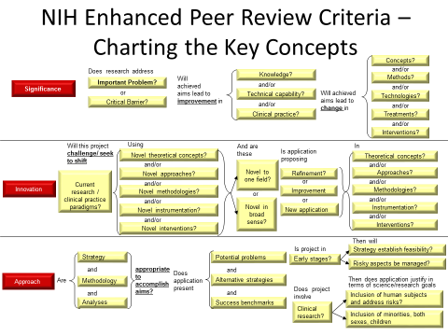

<https://grants.nih.gov/grants/peer/guidelines_general/Review_Criteria_at_a_glance.pdf>

<https://grants.nih.gov/grants/peer/guidelines_general/Review_Criteria_at_a_glance-research.pdf>

# Training to use the Rush Research Portal (RRP) and conduct research at Rush

### For CITI Training

Log on directly to: https://www.citiprogram.org

* Create a user account. If you already have a user account then see the next bullet.
* Affiliate with RUMC then follow the directions for registering as Rush personnel.
* New, as of January 2017,
  + when you have to renew your annual training which includes Basic course
  + the next refresher course will be in 2020
  + another refresher course in 2023
  + refresher course in 2026 (with SocioBehavioral redo Refresher 1)
  + Basic again in 2029
* Complete the required modules (auto-populated dependent on type of research

conducted).

More questions?

Tony DeMarco

RRP Specialist and Webmaster

Research Administration Technologies

ORA

312-942-5097

Antonio_S_Demarco@rush.edu

OR

Stephanie Guzik

Director, Research Compliance

312-942-1296

Stephanie_Guzik@rush.edu

Research Portal Training led by Antonio DeMarco Antonio_S_Demarco@rush.edu

Onboarding is taught by Stephanie Guzik or her colleagues. All new research staff will receive training on

research compliance matters through the research onboarding program. Sessions are held every Friday at 10 a.m. I am recommending everyone go to this at some point. These are the folks who will help you prepare for any possible audits.

See later sections on Good Clinical Practice:

### How do I get access to the Rush Research Portal (RRP)?

Training sessions are held every Friday at 11 AM as part of the Research onboarding program. Access to the RRP will be granted after research compliance training (10 AM) and the portal training (11 AM) sessions are completed.

Tony DeMarco

RRP Specialist and Webmaster

Research Administration Technologies

ORA

312-942-5097

Antonio_S_Demarco@rush.edu

## Research Portal Training

### How to Set up your Master Project and its Components:

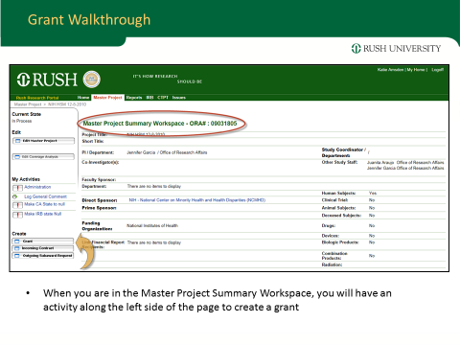

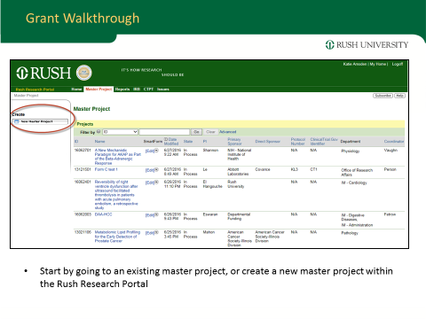

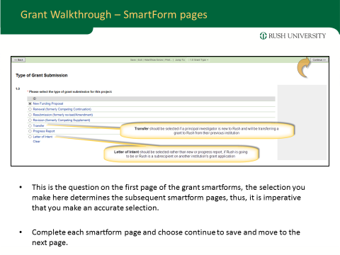  
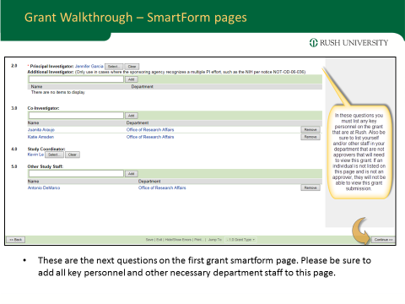

## Grant SmartForms in Rush Research Portal

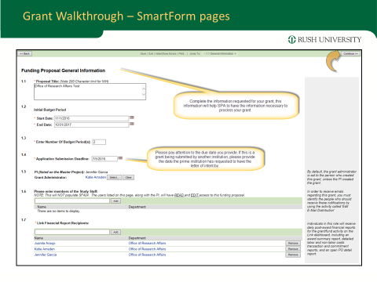

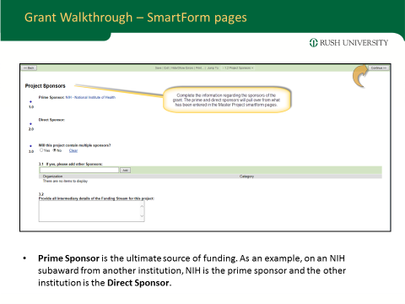

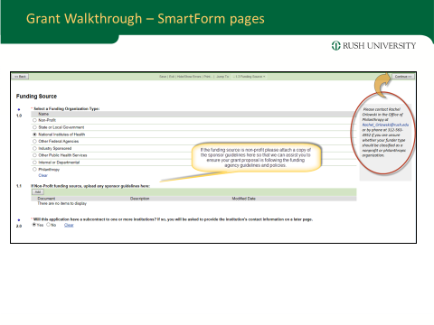

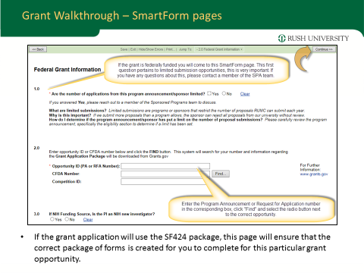

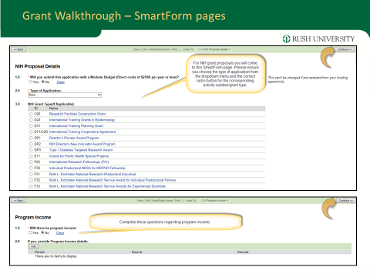

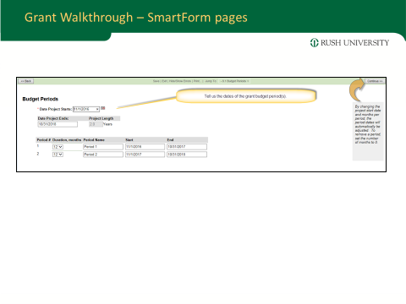

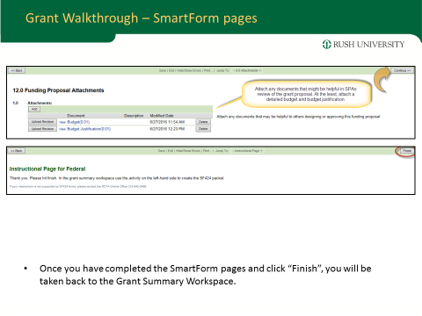

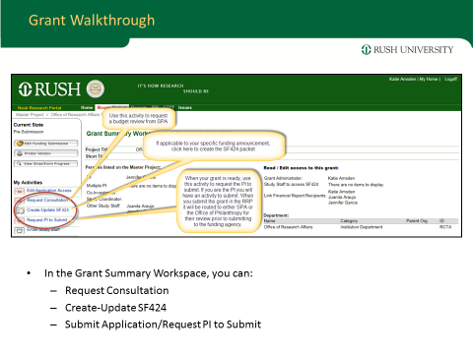

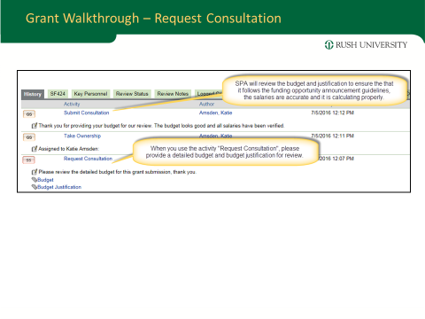

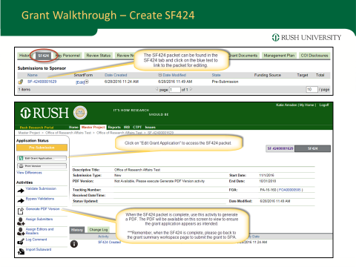

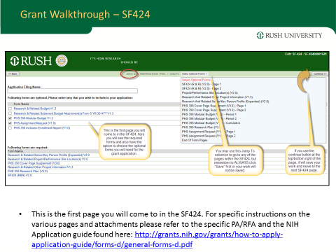

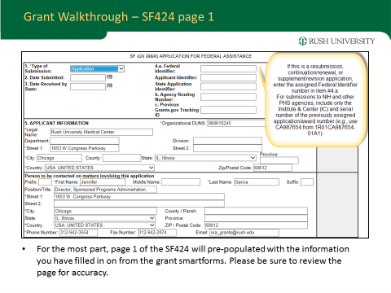

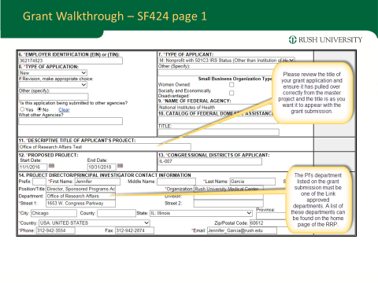

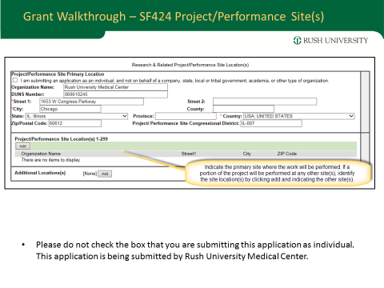

# Does my research require IRB review?

## 

## Research with de-identified human data or specimens or not human subjects research”(NHSR)

The Division of Research Regulatory Operations, Office of Research Affairs keeps track of research activities which use de-identified human data or specimens but do not meet the definition of Human Subjects Research.  **Research Regulatory Operations determines whether the research activity involves human subjects or not.  If the research activity involves human subjects, it will require IRB review.**

* One goal is to improve our response time to your submissions and the quality of documentation. In an effort to improve the process of making these determinations,
* A new electronic submission form (Form 118) that can be submitted via REDCap directly to Research Regulatory Operations. (Previously, Form 118 had to be submitted to Research Regulatory Operations in paper format via hand delivery or e-mail).
* Examples of studies that may fit the definition of NHSR under federal regulations can include
  + studies only using publicly available data,
  + case reports, or
  + studies intended solely for quality or program improvement at Rush.
* For any questions regarding what may qualify as NHSR or how to fill out the new Form 118, please feel free to contact Research Regulatory Operations at 312-942-3606 or email [Reva_T_Wymbs@rush.edu](mailto:Reva_T_Wymbs@rush.edu).
* To get started on your Form 118 submission now, you may go to <https://redcap.rush.edu/redcap/surveys/?s=LWREMPAE4X> (please save this as a favorite in your browser for easier access).

## Master Document

The Master document is important even when no grant is being submitted. Once a master document is created and submitted, the initial fields of the IRB documents, the Coverage Analysis, the Grant or Contract will be populated based on the contents provided in the Master Document.

The next step prior to any review by Coverage analysts or IRB consultants, etc. is Departmental approval. One the front page of the Research portal, all departmental approvers are listed. Generally this is the chair of the department or the Associate Dean of Research.

## Coverage Analysis

Coverage Analysis is performed by Clinical Research Administrators in the Office of Research Affairs to ensure that appropriate billing has been added. Once approval is granted, documents can then move to the next step---usually a review by the IRB consultant. If they have any questions, it will be communicated to you through the portal through your email.

### If have questions about coverage analysis; who should I contact?

Fasihuddin Mohammed, Coverage Analyst, Clinical Research Finance, Clinical Research Administration

ORA, 312-563-2715, Fasihuddin_Mohammed@rush.edu

### 

### IRB or Institutional Review Boards

### .

The IRB consultant is communicating with you often if your application is unclear or missing certain elements. Their job is to ensure when the application does go to the IRB committee for review, if needed, that all the components are there so approval may be granted.

## If I have questions about the IRB application; whom should I contact?

Elanda Shannon, IRB Administrative Assistant, Research Regulatory Operations, ORA

312-563-2721, Elanda_T_Shannon@rush.edu

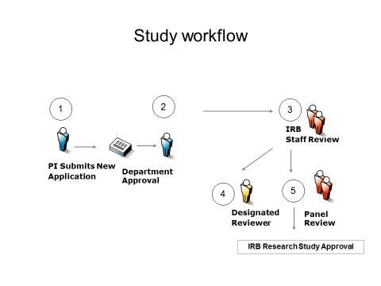

## What does it mean when my study is in pre-submission in the RRP?

While you are working on an application, the status will stay in pre-submission until the Submit

button is pushed. The ORA staff is unable to view studies in the pre-submission state. Double-check

whether the **submit** button has been activated by the PI and/or Department Chair if the study is unexpectedly in the “pre-submission” state.

## My study will involve an investigational device (e.g., IDE). Who do I call with questions?

## 

A medical device is an instrument, apparatus, implement, machine, contrivance, implant, *in vitro*

reagent, or other similar or related article, including any component, part, or accessory, which is intended for use in the diagnosis of disease or other conditions, or in the cure, mitigation, treatment, or prevention of disease in man. Clinical studies of medical devices must comply with FDA human subject protection requirements and Medicare requirements. Some types of device trials need to be submitted to Medicare.

Contact Allecia Harley, Associate Vice President, Clinical Research Administration, ORA, 312.536.2780, Allecia_Harley@rush.edu

# Developing and submitting a grant application is a team effort.

* Meet with your Office of Sponsored Research (or central grants support office) early in the process. :
  + Are you registered in the eRA Commons?
  + Guide you through the application process and inform you of any institutional deadlines you must meet;
  + Guidance on NIH policies and processes;
  + Advice on developing your application, especially budget.
  + Plan your timeline to ensure you get your application to your Office of Sponsored Research on time, especially when collaborating investigators are involved.
  + Find experienced staff at your institution to assist you in understanding all the steps necessary to complete your application.
    - central grants office, or
    - departmental administrator, etc.

# Who do I need to contact if it is a Contract? Subcontract?

Erin Kampschmidt (Industry Sponsored Contracts)

Contract Specialist

ORA

312-942-3310

OR

Juanita Araujo

Grant and Subcontract Specialist

ORA

312-942-2411

# 

# When a substantial portion of the work in a Rush Award is being done by others, you need an Outgoing SubAward request and these same individuals can be contacted.

The Sponsored Programs Administration division of Research Affairs wanted to make you aware of a **new module within the Rush Research Portal for use with Outgoing Subaward requests**.

* Outgoing subaward agreements are used when a substantive portion of the programmatic work outlined in a Rush award needs to be conducted at another organization.
* **The purpose of the *outgoing* subaward module in the research portal is to route your request to the Office of Research Affairs to set-up an outgoing subaward agreement with another institution/subrecipient, from a grant award received by a Rush Principal Investigator directly from the awarding agency**.

Please keep in mind that many of your requests for outgoing subawards will be amendments to already existing subawards. In planning for these amendments, we have created subaward shells within your already existing master project in the portal so that you may go in and create an amendment request under the shell. If you do not see a shell in your corresponding master project, please contact a member of the SPA team so that we may assist you. Attached is a walkthrough for how to use this new module.

Please note:       All *incoming* subaward agreements should continue to be routed through the ‘Incoming Contract’ module of the Research Portal.  An incoming subaward occurs when another institution receives funding and subawards a portion to Rush.

We would also like to take this opportunity to share with you a budget template we developed for grant proposals.  The budget includes auto-calculating features to calculate the most current approved fringe benefits and indirect cost rate as established by the current rate agreement, as well as imposing the correct calculation rules regarding those items that do not incur F&A.  We encourage Investigators and departments to use this template going forward. The instructions for using the template can be found on the “Instructions” tab of the workbook. Please feel free to share this template with other staff and investigators you work with!

As always, please don’t hesitate to reach out to us (Office of Sponsored Programs) with any questions you may have.

# What if I plan to use someone else’s data?

The best place to start is here on the research portal: <https://rrp.rush.edu/researchportal/Rooms/DisplayPages/LayoutInitial?Container=com.webridge.entity.Entity%5BOID%5B1CDA8F3E2B82EA4D930E07F36BF83776%5D%5D>  
There you will find the standard operating procedures for reviewing **data use agreements** (as well as **material transfer agreements**) and the current templates. Much of this information again is available on the RRP on the leftmost column once you login…..

|  |  |  |  |
| --- | --- | --- | --- |
| |  |  | | --- | --- | | Intellectual Property Documents |  | | |
|  | https://rrp.rush.edu/Common/_RushProd/84eeb60129b349c18537cf126f925485/Images/layout/spacer.gif |

|  |  |  |  |  |  |  |  |  |  |  |  |  |  |  |
| --- | --- | --- | --- | --- | --- | --- | --- | --- | --- | --- | --- | --- | --- | --- |
| |  | | --- | |  | | |  |  | | --- | --- | | [Name](https://rrp.rush.edu/researchportal/Rooms/DisplayPages/LayoutInitial?Container=com.webridge.entity.Entity%5BOID%5B1CDA8F3E2B82EA4D930E07F36BF83776%5D%5D) | [Modified Date](https://rrp.rush.edu/researchportal/Rooms/DisplayPages/LayoutInitial?Container=com.webridge.entity.Entity%5BOID%5B1CDA8F3E2B82EA4D930E07F36BF83776%5D%5D) | | [Material Transfer Agreement](https://rrp.rush.edu/researchportal/Doc/0/30MSSR9CS9U499FVD5P569L8EE/MTA.DOCX) | 5/4/2016 3:36 PM | | [Material Transfer Agreement and Data Use Agreement SOP](https://rrp.rush.edu/researchportal/Doc/0/LTKC76AHV8343A3MG02H9KGK4B/MTA.DUA%20SOP%204.20.16.docx) | 5/4/2016 3:37 PM | | [RUMC Data Use Agreement](https://rrp.rush.edu/researchportal/Doc/0/DK3MVKQVSBK4JC0O5VM7FD9K0B/RUMC%20Data%20Use%20Agreement.docx) | 5/4/2016 3:38 PM | | [The Uniform Biological Material Transfer Agreement](https://rrp.rush.edu/researchportal/Doc/0/3EQR3E4T60SKL9NGHOM5Q4QA75/The%20Uniform%20Biological%20Material%20Transfer%20Agreement.docx) | 5/4/2016 3:39 PM | | [UBMTA Implementing Letter](https://rrp.rush.edu/researchportal/Doc/0/BAOCHHTTEM2K1FKDIDKRT12774/UBMTA_Implementing_Letter.doc) |  | | |

# What happens if the award is ***being applied*** for or coming from a foundation?

*What is a philanthropic grant? Most non-federal and non-industry sponsored grants that are funded by private corporations, foundations or organizations are considered philanthropic. If you are unsure, please call Carrie Roche at x2-4611 to confirm.*

**Pre-submission of grant proposal:**

For *research* grant proposals:

1. Create a new master project and new grant within the Rush Research Portal.
   1. Select “Philanthropy” as the ‘funding type’ within the portal
2. Submit the grant through RRP for Department and Philanthropy approval

For *non-research* grant proposals (fellowships, scholarships, community programs, etc.):

1. Please let your Philanthropy contact (or Carrie Roche) know of your plan to submit a philanthropic grant proposal
2. Philanthropy will review your budget and proposal before you submit to the funder

# NOW YOU HAVE THE GRANT/CONTRACT…

# Just-In-Time (JIT) via eRA Commons

Only After JIT request is received **(via email, letter or telephone call)** from NIH: The Principal investigator is responsible for preparing the JIT information and uploading all requested documents to the NIH eRA Commons website. Once complete the investigator must notify Sponsored Programs Administration (SPA) by phone or email. SPA will review and submit via the eRA Commons website.

**Principal Investigator (or PI’s designee) will:**

• Log on to eRA Commons at https://commons.era.nih.gov/commons/

• Click on the “Status” at the top and select “Just In Time” on the left

• Search by Grant number, PI name etc.

• Click on the “JIT” link under the “Action” column

• Import or enter the required information:

o Import in PDF the Other Support document and please be sure to include the pending grant the JIT information is being submitted for. (https://grants.nih.gov/grants/funding/phs398/phs398.html)

o Import a copy of the budget, only if specifically requested by the NIH

o Provide IACUC approval date, if applicable

o Provide IRB approval date, if applicable

o Provide Human Subjects Federal Wide Assurance (00000482) or Animal Welfare Assurance Number (A3120-01), if applicable

o Provide Human Subjects Education certificates for all key personnel, if you are unable to obtain these, please provide in an email to SPA the full names of all key personnel on the grant.

Note: option to enter dates/upload documentation is only available when animals and/or humans are being used

• Press the SAVE button

• Click “View Just In Time Report” to make sure everything looks as intended

• Department Administrator should review for accuracy

• PI or Department Administrator needs to inform SPA that the JIT is ready on eRA Commons and also e-mail applicable IACUC and IRB approval letters. Note: eRA Commons does not send emails to the Grants office informing us that a JIT is awaiting our approval.

**Sponsored Programs Administration will:**

• Review JIT Report from eRA Commons and verify information

• If changes are needed we will contact the PI or Department Administrator, so that the PI (or designee) can update and save information on eRA Commons

• PI or Department Administrator needs to contact Sponsored Projects after changes are made

• When no changes are needed, we will submit.

Version: 06/21/2016

Please contact a member of the Sponsored Programs Administration division with additional questions:

Jennifer Garcia

Director, Sponsored Programs Administration

312-942-3554

Jennifer_Garcia@rush.edu

Juanita Araujo

Grant and Subaward Specialist

312-942-2411

Juanita_Araujo@rush.edu

## Post-submission of philanthropic grant proposal:

*After you have submitted an application,* ***please inform philanthropy once you hear from the funder.***

**If declined of funding**, please let us know so we can track this. **If approved**, please follow these steps:

1. **Inform your Philanthropy contact upon receiving notification of your approval for funding**
   1. Send award notice to Philanthropy contact—
   2. We will mark it as a pledge in our system
2. **Send the grant agreement to your Philanthropy contact before signing**. Grant agreements need to be approved by legal and then signed by an institutional officer (from Philanthropy)
   1. Philanthropy will assist in getting the agreement approved, signed and returned to either the PI/staff or the funder.
3. **Confirm if you will need a new activity number**. Many philanthropic grants will have financial reporting requirements, signifying that you will need to create a new activity to track expenditures for this grant. If the grant is small (less than $25K) and/or no financial reports are required, please let Philanthropy know what activity number you would like to deposit the grant into, as no new activitycreation is necessary.
   1. Philanthropy will begin the new activityform and send to PI/admin and to Dr Tangney (CHS Associate Dean for Research) and Natalie Landfair (CHS Financial analyst) to obtain signatures
   2. Once all signatures are obtained—including Research Affairs, if needed—please return to Philanthropy (Olga Bugarin), who will work with Fund Accounting Dept and Natalie Landfair to set up a new activity.
4. **Once a check is received, please forward it directly to your Philanthropy contact.**
   1. Philanthropy will deposit the check into the new **activity number** or the activity that was requested. If the new activitycreation is still in process, then the check will be deposited into a “suspense” activity until the new activity number is created through Fund Accounting. *Philanthropy will send an acknowledgment to the funder*.
5. **Ensure that you have recorded all reporting deadlines—send reports to the funder on time!**

Failure to meet reporting requirements could affect future funding for you or other Rush investigators. Discuss with your philanthropy contact who will lead in reporting to the funding sponsor.

## Purchasing:

The Link team has created step-by-step instructions to guide employees through the “Procure to Pay” process. Click [here](https://link.rush.edu/Documents/Req%20and%20Invoice%20Approval%20Reminder%20v7.pdf) for a comprehensive look at the process for requisitions, purchase orders, check requests, invoices and expense reimbursements. The information also is included below.

If you have a question about a specific step in the “Procure to Pay” process, see the links below.

* Click [here](https://link.rush.edu/Documents/p2p%20submit%20a%20req.pdf) for information on **how to submit and obtain an approved requisition**.
* Click [here](https://link.rush.edu/Documents/p2p%20how%20to%20issue%20purchase%20order.pdf) for information on **purchase orders.**
* Click [here](https://link.rush.edu/Documents/p2p%20vendor%20submits%20invoice.pdf) for information on **invoices**.
* Click [here](https://link.rush.edu/Documents/p2p%20check%20requests.pdf) for information on **check requests**.
* Click [here](https://link.rush.edu/Documents/P2P%20expense%20reimbursements.pdf) for information on **expense reimbursements**.

## Step 1: Submit and Obtain Approved Requisition

The first step in ordering supplies or services is submitting a requisition***.*** A requisition is an electronic request for goods or services that is placed in the Link system by an approved requestor. To become an approved requestor, you must complete online training, and your manager must fill out this [form](http://inside.rush.edu/Departments/SupplyChain/Lists/New%20Requester%20Form/Item/newifs.aspx?List=5d0e747d-4f72-4031-b051-935bbfb3878c&RootFolder=&Web=f7104fd0-462d-4bfa-a9e2-39fe005fe9f9).

Requisitions route for approval based on the accounting unit and the dollar value of the request.  See the standard approval grid below:

|  |  |  |
| --- | --- | --- |
| **Dollar Amount** | **Approval Needed** | **Leadership Level** |
| $0 - $500 | No Approval | N/A |
| $500 - $2,500 | Level 1 | Administrator |
| $2,500 - $25,000 | Level 2 | Manager |
| $25,000 - $100,000 | Level 3 | Director |
| $100,000 + | Level 4 | AVP or VP |

Please note:

* You cannot approve your own requisition.
* The approval table is maintained in Financial Information Services, and is determined by your VP.
* There is a 48-hour escalation process, whereby if a requisition remains at an approval level for two business days, it is automatically escalated to the next level.  If no action is taken after six business days, a requisition will be returned to the requestor.

## Step 2: Issue Purchase Order

Once a requisition is approved, a purchase order (PO) is generated, with a PO number. A PO is a document issued by a buyer to a seller, in this case, Rush to a vendor. It indicates types, quantities, agreed prices and terms and conditions for products or services. It is used to control the purchasing of products and services from external suppliers.**POs must be issued in advance of goods being ordered and received and services being rendered and performed. The PO number is required to be included on invoices.**

The PO number must be communicated to the vendor.  POs are generated by the Link system and automatically routed through the Link system by fax, email or EDI to the vendor.  Employees who are set up as requestors can find the PO number by going to the Requisition Status link on the [Link page](https://link.rush.edu/Pages/Default.aspx). In the Purchase Requesters & Approvers column under Requisitions & POs, select View Requisition Status.

POs are required for all vendors that provide supplies, minor equipment or services.  Examples include, but are not limited to, medical supplies (wound care, gowns, drapes, implants), routine supplies (medical gases) and services (janitorial, repairs, consulting services, independent contractors).

Some items and services, such as membership dues and subscriptions, do not require a purchase order and can be paid by check request. See details under **Check requests** below for additional information.

## Step 2B: When the purchase is a computer….

## Step 2C: When your purchase is for an item that exceeds $5000

## Step 3: Vendor submits invoice

An invoice is an itemized bill for goods sold or services provided.

**Each invoice must reference the PO number it is related to.  Invoices without a PO number will not be processed for payment and may be returned to provide more information or go through the requisition process**.

Per the PO terms and conditions, invoices must be submitted to Accounts Payable using the Rush Accounts Payable PO Box.

* Rush University Medical Center

Attention:  Accounts Payable

PO Box 7715

Chicago, IL 60680

* If the vendor does not comply with using the PO Box, please hand deliver invoices to accounts payable, located in Rush University Medical Center TOB Room 285, or the ROPH finance department office, on Rush Oak Park Hospital’s fifth floor.

Invoices for supplies/goods must have a matching PO. All goods/supplies / equipment must be received in Link and certain equipment might also need to go through inspection process in Link before the invoice is paid.

Invoices for services follow an electronic routing approval process after Accounts Payable enters them into Link based on service PO information. The electronic approval process flow follows the approver table listed below:

|  |  |  |
| --- | --- | --- |
| **Dollar Amount** | **Approval Needed** | **Leadership Level** |
| $0 - $100,000 | Level 2 | Manager |
| $100,000 + | Level 4 | AVP or VP |

Please note:

* There is a five-day escalation process, whereby if a service invoice approval remains at a Level 2 for five business days, it is automatically escalated to the Level 4 approver. Service invoices also can be submitted as pre-approved with appropriate signature authority level.

## Check requests

Check requests are used only for items that do not require a PO. These generally include one-time expenses or purchases processed without the purchasing department’s involvement. Examples include subscriptions, agency fees and membership dues.

A check request form is required to be completed and approved, and should include an attached invoice. Check request forms and the supporting invoice must be submitted to accounts payable, located in TOB Room 285 or the ROPH finance office, on Rush Oak Park Hospital’s fifth floor. The form can be accessed via the [Link page](https://link.rush.edu/Pages/Default.aspx) under the Employee column by selecting Finance/Reimbursement, or by clicking [here](https://link.rush.edu/finance/Documents/AP%20Check%20Request%20Form.pdf).

The grid for check request approvals is as follows:

|  |  |  |
| --- | --- | --- |
| **Dollar Amount** | **Approval Needed** | **Leadership Level** |
| $0 - $2,500 | Level 1 | Administrator |
| $2,500 - $25,000 | Level 2 | Manager |
| $25,000 - $100,000 | Level 3 | Director |
| $100,000 + | Level 4 | AVP or VP |

## Expense reimbursements

Expense reimbursements are for Rush employees for out-of-pocket expenses related to Rush business or incurred while traveling for Rush business, and are only reimbursed by the payroll department.

The expense reimbursement form is required to be completed and approved, and must include attached supporting documentation. The forms and documentation must be submitted to payroll, located in TOB Room 150 or the ROPH payroll office, on Rush Oak Park Hospital’s fifth floor, within four weeks of the occurrence or date of return. Please note that all travel-related expenses must be pre-authorized. The expense reimbursement form can be accessed via the [Link page](https://link.rush.edu/Pages/Default.aspx) under the Employee column. Under Finance/Reimbursement, select Submit an Expense Form. The form also is available [here](https://link.rush.edu/finance/Documents/Rush%20Employee%20Expense%20Report%204.xlsm). Please check with your department if additional signatures are required.

Employee expense reimbursement form approvals are as follows, and must be approved by a Level 2 or above:

|  |  |  |
| --- | --- | --- |
| **Dollar Amount** | **Approval Needed** | **Leadership Level** |
| $0 - $25,000 | Level 2 | Manager |
| $25,000 - $100,000 | Level 3 | Director |
| $100,000 + | Level 4 | AVP or VP |

A number of new resources have been developed by the Supply Chain team to assist employees who request supplies and services through Link. These tools have been created to meet the needs of employees who order for multiple areas, particularly for those associated with research.

You will use an accounting unit to initiate a process or transaction – cost centers no longer will be used. All departments’ cost center numbers have been replaced with accounting unit numbers. The accounting unit has 9 digits and 2 dashes. As done with the previous system, a 5-digit account number is used to provide a description of the expense and/or revenues charged to the accounting unit. Please note: All account numbers will change. To receive new accounting unit and account numbers, use the legacy look up tool.

Requesters who order for multiple companies across different parts of the organization should reference the following tip sheets. The company is the first two numbers in the accounting unit. A list of companies is available on the Link resource page.

**Monthly In-Person Training**

The Supply Chain team will hold monthly training and information sessions on using the Link Requisition Center. These 60-minute sessions will cover the most frequently asked questions and common issues in an effort to provide additional support to purchase requesters. These sessions are intended for new purchase requesters and existing requesters who would like more information about the Requisition Center. Each session will include time for questions.

Sessions are being held at both Rush University Medical Center and Rush Oak Park Hospital. To be eligible to attend, you must complete the mandatory online training in LEAP Online and pass the assessment test. Instructions on this process are found below.

## How Can I Order Supplies through Link?

You will first need to become a requester in Link to be able to order supplies. You can access the requester form in Link under Requisitions & POs and click “Add New Accounting Units or New Requesters.” The screenshot below also points to where you can find the form.

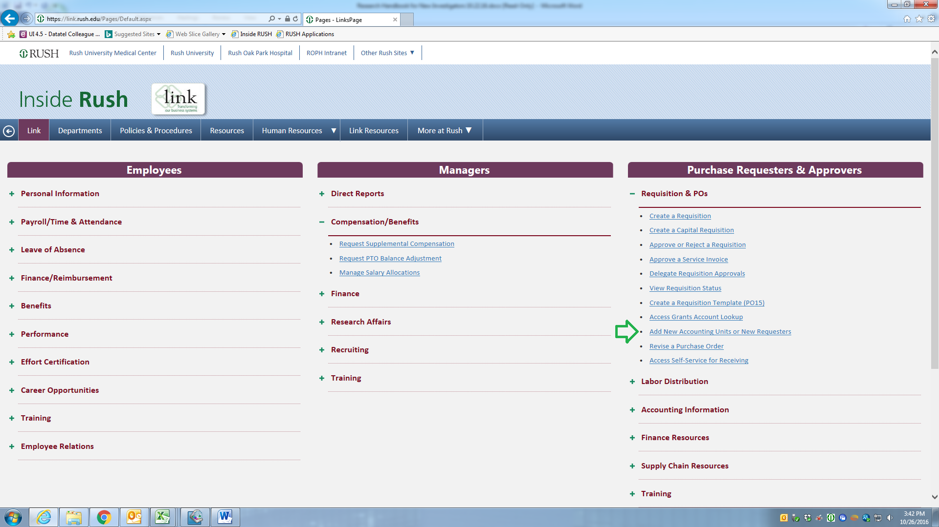

Your manager (Natalie Landfair) will need to fill out the New Requester form. If your manager is not familiar with this form the screenshot on the next page provides an example of how to fill out the requester form for a grant/contract. If this is the first time that requester status is being requested for you, then “under requester status” your manager will mark “new”. If you are already a requester but under a different accounting unit, then your manager will choose “existing” and update the form with the accounting unit associated with the grant/contract. It is important that for the section *Grants & Funds Requester* and the section *Additional Accounting Units*, you select “Yes”.

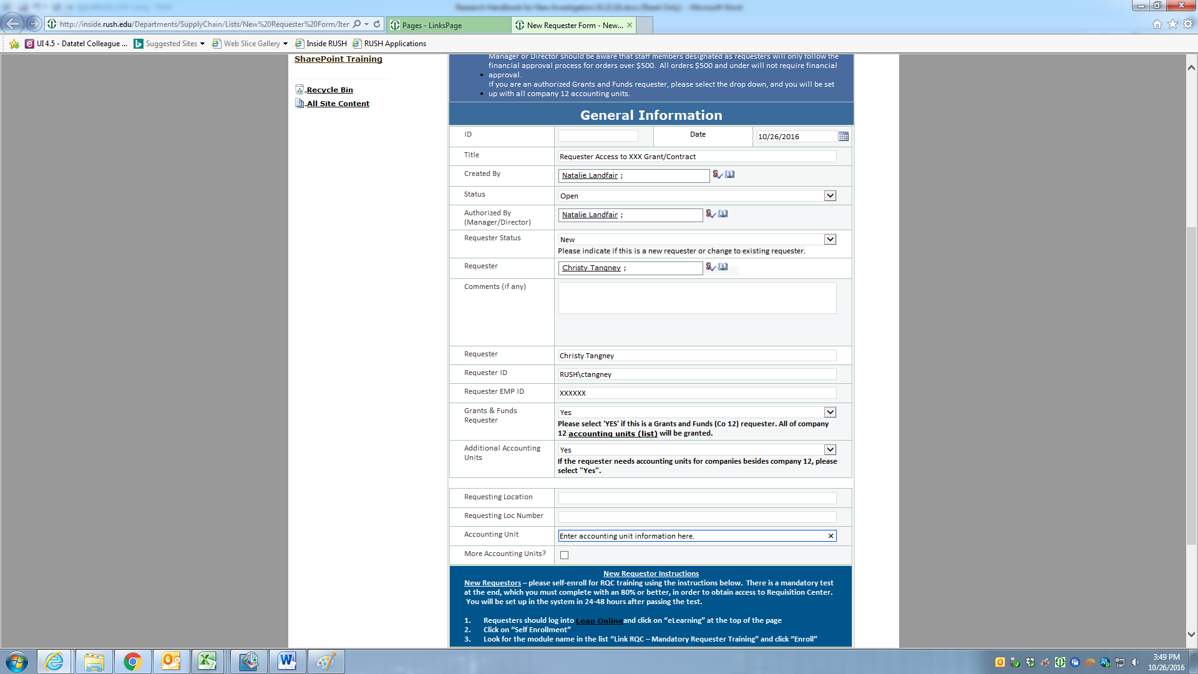

# 

# 

# Once your manager has completed the New Requester form, follow the steps below:

1. Log into [LEAP Online](https://login.elsevierperformancemanager.com/systemlogin.aspx?virtualname=rush) and click on “eLearning” at the top of the page.
2. Click on “Self Enrollment.”
3. Look for the module name in the list “Link RQC – Mandatory Requester Training” and click “Enroll.”
4. Users who pass the assessment with a score of 80 percent or higher will be granted RQC access in about two business days.

If you do not have access to Link after following the steps above, Alfredo Herrada in Supply Chain can be of assistance. His email address is [alfredo_herrada@rush.edu](mailto:alfredo_herrada@rush.edu), and his extension is x2-1433.



## How can I order supplies now that I am a requester?

Now that you are a requester you can order supplies through Link. On the Link homepage click on Create a Requisition under the section, Requisition & POs.

Before you begin ordering supplies, you will need to determine whether the vendor you are ordering from is a “PunchOut” or a “Special/Service”. The majority of vendors that you will use will fall under the “Special/Service”.

PunchOut vendors include:

* Bio-Rad
* CDW G
* Cardinal Health
* CINTAS
* Fisher HealthCare
* Fisher Scientific
* Grainger
* HP
* Life Technologies Corp (Thermo Fisher Scientific)
* Sigma-Aldrich
* Standard Register
* VWR
* Warehouse Direct

NOTE: If you need to place an order with a PunchOut vendor and a Special/Service vendor you will need to do a separate order for PunchOut and Special/Service.

## `

* 1. On Link homepage under Requisitions & POs select, Create a Requisition
  2. Select the Basic Tab if you are not already defaulted to the tab, and follow the instructions below:

Under the **Basic** Tab

* Fill in requesting location, for researchers who work in suite 1001 AAC your requesting location is **60101**. You can also click on the icon next to the box to see what number is associated with your location in Link.

Under the **Detail Profile** Tab

* Skip this tab

Under the **Accounting** Tab

* Make sure to select **0012 under Distribution Company** – this selection is only for grants/funds. For all accounting units starting in 10, select 0010 under Distribution Company.
* Fill in Accounting Unit, Account, Activity and Account Category as shown in the example below.
* Note: Account and Account Category will always be the same. In the example below, the account category 051000 stands for medical supplies, which will be commonly used if you are ordering research supplies. If you click on the magnifying glass next to account and account category you can select the appropriate account from a list.

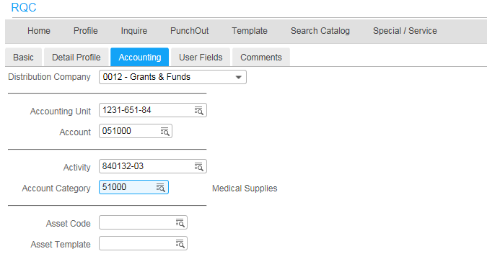

Under the **User Fields** Tab

* Skip this tab

Under the **Comments** Tab

* Select Comments to Print on Delivery Tickets
  + Fill in your name and office number in the comments box
    - Hit Update – confirm with Alfredo this is correct
  1. You are now ready to click on the PunchOut Tab
  2. Select the appropriate vendor by clicking on the vendor’s icon.
  3. The following message will appear on your screen, “You are now leaving your company’s Requisition Center website.”
     1. Select OK
  4. Now that you are on the vendor website, add the research supplies to the cart.
  5. Once you are done selecting all of the supplies you need, go to your cart and there should be an option to “return to the purchasing application”. This statement may vary slightly depending on the vendor.
  6. You should now see the items you selected on the right hand side as depicted below:

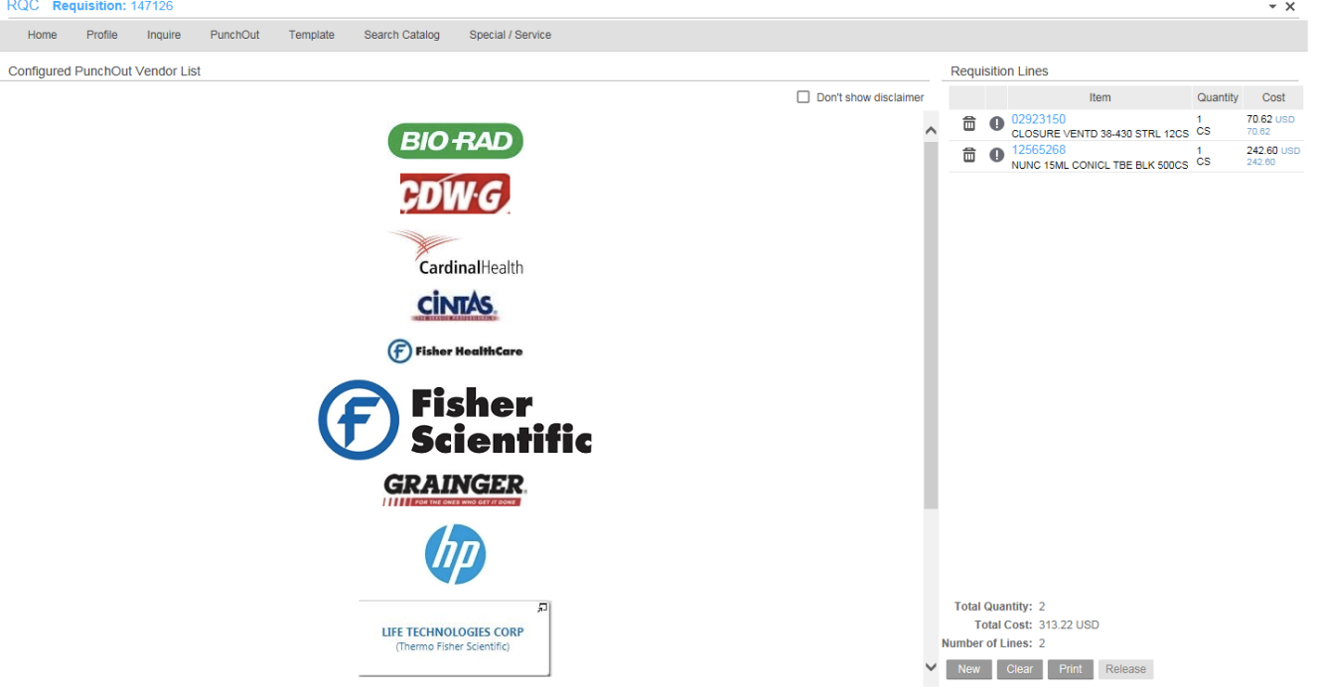

* 1. Click “Release” at the bottom right corner for your order to be processed.

How to Place an Order with a Special/Service Vendor?

* 1. On Link homepage under Requisitions & POs select, Create a Requisition
  2. Select the Basic Tab if you are not already defaulted to the tab, and follow the instructions below:

Under the **Basic** Tab

* Fill in requesting location, for researchers who work in suite 1001 AAC your requesting location is 60101. You can also click on the icon next to the box to see what number is associated with your location in Link.

Under the **Detail Profile** Tab

* Skip this tab

Under the **Accounting** Tab

* Make sure to select 0012 under Distribution Company – this selection is only for grants/funds. For all accounting units starting in 10, select 0010 under Distribution Company.
* Fill in Accounting Unit, Account, Activity and Account Category as shown in the example below.
* Note: Account and Account Category will always be the same. In the example below, the account category 051000 stands for medical supplies, which will be commonly used if you are ordering research supplies. If you click on the magnifying glass next to account and account category you can select the appropriate account from a list.



Under the **User Fields** Tab

* Skip this tab

Under the **Comments** Tab

* Select Comments to Print on Delivery Tickets
  + Fill in your name and office number in the comments box
    - Hit Update – confirm with Alfredo this is correct
  1. You are now ready to click on the Special/Service Tab
  2. Follow the example below to place your order:
  3. NOTE: If you are ordering multiple items, you will need to complete the steps below for each item.
     + - 1. Item: this work best if you have the category number. You can always search the catalog to find the category number as well.
         2. Description: provide a brief description of the item you are ordering.
         3. Item Type: Special
         4. If you were ordering a service such as CO2 tank, you would put quantity service instead of special
         5. Quantity: Enter the amount of the item you would like to order.
         6. UOM: Click on the magnifying glass to the right of the box. Commonly used Unit of Measure’s includes Vial (VL) and Pack (PK).
         7. Cost: The cost can also be found in the catalog.
         8. Cost Default Vendor: Click on the magnifying glass to the right of the box. You can search for your vendor in the box that opens up.
         9. PO Code: Leave blank.
         10. If you are ordering a service such as the CO2 tank, then you would type SVC.
         11. Confirm all information is correct and click Add. If you need to order more items from a Special/Service vendor follow steps 1-8 for each subsequent item. Once you have ordered all of your items, click Release.

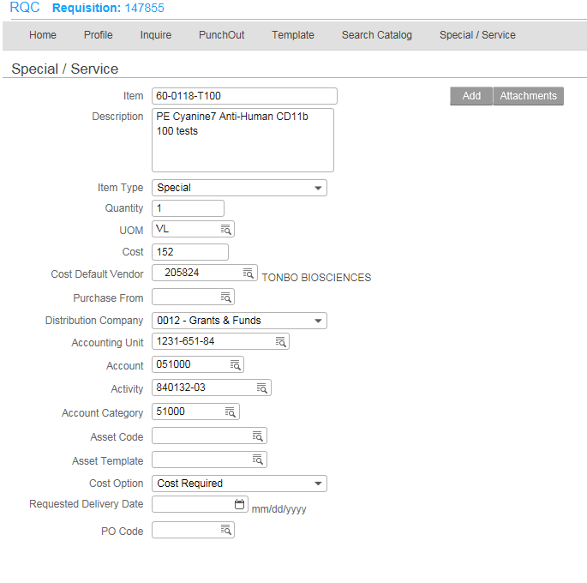

## How Can I View the Status of My Order?

On the Link homepage, click on create a requisition. Then go to the Home tab at the top left. You should then see a list of your requisitions that you have created. Below is a number of scenarios that you may see under status:

* Unreleased – this means that you did not release the order. You will need to go into modify from the home screen and release the order.
* Needs Approval – the order is awaiting approval.
* Processed – this means that the order is in process but has not yet been completed.
* Closed – this means that the order has been delivered and is completed.

Contacts in Purchasing for Questions Relating to an Order:

Jane Carrino – Buyer for the College of Health Sciences

[Jane_P_Carrino@rush.edu](mailto:Jane_P_Carrino@rush.edu)

x2-5409

Steve Hamilton – Manager, Supply Chain

[Steven_Hamilton@rush.edu](mailto:Steven_Hamilton@rush.edu)

x2-5156

## How do I check on the progress of my warehouse orders?

Purchase requesters can check the progress of their warehouse orders using online tools located under the Purchase Requesters & Approvers tab on the [Link page](https://link.rush.edu/Pages/Default.aspx). Here are some commonly asked questions about tracking warehouse orders.

1. **Is the item I need in stocked in the warehouse?**
2. When placing your order, you can check on whether your item is available, and how much stock is on hand. Refer to the “Available” file in the “Search Catalog” tab in the Link Requisition Center.  As a reminder, stock on hand is a constantly moving target due to order and replenishment.
3. **What if I need more than what we have in stock?**
4. If you place an order but there is insufficient stock available at the warehouse, the line will be “killed.” You will not receive the killed quantity in your delivery, but the quantity filled, along with the other items on your requisition, still will be delivered to you.
5. **How do I get the rest of my order?**
6. When you are reviewing the status of your requisition, items that are killed from your requisition will appear in red, with a quantity killed. Users will have to reorder the quantity killed at a later time as items no longer go into a backorder status. Please refer to the “Available” field in Link to know when there is stock on hand available for reorder.   A job aid for reviewing the status of your requisition can be found [here](http://inside.rush.edu/Departments/Corporate/Committees/Link/Documents/Check%20Requisition%20Status.pdf). See Page 3 for more information on Fill/Kill.
7. **Will I get an email letting me know if items are killed?**
8. It is important to check the status of your requisitions on a regular basis. You will not receive an email alerting you if an item has been killed.

## How do I find out what budget categories are and are not allowable on my grant?

## 

This will always depend on the award/sponsor – Costs must be allowable under the provisions of the sponsor guidelines, and the terms of the specific award.

For example, all federal awards are subject to the 2 CFR 200 Uniform Administrative Requirements, Cost Principles, and Audit Requirements for all Federal Awards – Better known as Uniform Guidance.  Specifically Subpart E—Cost Principles details out what is allowable on a federal award (<http://www.ecfr.gov/cgi-bin/text-idx?SID=5116262536a9cbcdadc0cf295187e23d&mc=true&node=sp2.1.200.e&rgn=div6>).

Below is a link to the NIH Policy on Allowable and Unallowable Cost.  It is important to reference these policies at the time of the proposal/budget development because they can help guide the PI on the development of the budget.

<https://grants.nih.gov/grants/policy/nihgps/HTML5/section_14/14.10_allowable_and_unallowable_costs.htm>

The best approach to guide faculty would be to review sponsor guidelines, award notices, and the application budget – If the cost was built into the budget and detailed in the budget justification at the time of the application, the sponsor’s award notice signifies their approval.  If they are still unsure, consult either ORA or fund accounting.

# How to Purchase a Computer/Laptop

* <http://inside2.rush.edu/departments/informationservices/apps/ComputerRequests/Pages/RequestForm.aspx>
* Complete and submit the form using the link above.
* If you are purchasing the computer/laptop from a grant or fund.
  + You will need to leave the AU section blank and enter both the accounting unit and the activity number in the comments section.
* If you need help selecting a computer or laptop you can reach out to the IS department for help. Check with Natalie or Dr Tangney if you need help here.

# How to purchase a computer/laptop that is not on the pre-approved list

* On the first page of the form, you must select something to buy such as a computer bag.
* Proceed to the second page of the form, and in the comments section specify that you do not want to purchase the computer bag but instead would like to purchase _____ computer/laptop.

## How do I access and read the accounting reports for my fund (awarded grant)?

Go to the LINK page (<https://link.rush.edu/Pages/Default.asp>) Under Managers in the center of the page click on “Research Affairs”, then “View Research Affairs Financial Reports”. You then will have to login again. You will next see the Dashboards for Research Affairs and under this, three types of reports

Labor Distribution Expiration Audit Report Award Expiration Report All Other Reports

Under this, the screen is split into two halves longitudinally the top all the awards you might have “Award Financial Status”& on the bottom, “Fund Balance” contains your activity units that are hot-linked. If you click on this activity number (six digits-four digits) it opens up a fund detail report. Key thing to remember here is that numbers in parentheses are in deficit.

If you have further questions, please contact Jane Winger at 2-9339.

## If I ship or receive hazardous materials do I need training?

Yes. There is LEAP online training that you can complete on Hazardous Material Dangerous Goods-Shipping Air. This is completed every two years or when changes are made to shipping regulations. Departmental Administrators assign this LEAP module to faculty and staff.

# Hiring Research Personnel

The first thing you might do is request access to iGreentree, which is our applicant tracking system.  WARNING: This program requires you use Internet Explorer but definitely NOT Google Chrome. Once an account in your name has been established, you will go to the web address:

Web Address: <https://rush.igreentree.com>

User ID: xxxxxxx

PW: Xxxx (case sensitive)

Also, for your reference attached is the GT Manager User Guide. If you need assistance in navigating the system let Angeles Tenorio | Sr. Consultant, Recruitment and Career Services | Human Resources x27036) know or your assigned recruiter will be able to assist. Of course, you will need to post a job description thought this system.

How do I create a position for a research staff member on a newly awarded grant? Contact either Angeles Tenorio or Lisa Schuller, HR Business Partner, X 2-2205



## 

## Who can answer questions about how to configure a position (e.g., job category, status, etc.)?

## If a staff member leaves my project, what do I have to do?

Contact either Angeles Tenorio or Lisa Schuller, HR Business Partner, X 2-2205

## 

## I need a research assistant, but don’t have money to pay them. Any suggestions?

Norma Sandoval, Administrative Manager for the Associate Provost of Research, Dr. Jacobs, maintains a volunteer list that you can access below. Research volunteer opportunities:

<https://www.surveymonkey.com/s/RushResearchVolunteers>

## How do I “on-board” Departmental or research volunteer?

A letter of introduction and job summary **must** be provided to the Office of Volunteer Services to verify the acceptance of the volunteer in your department. Please use the attached template. (see below) Please include name and most current email address as we will need to correspond with your volunteer to complete the on-boarding steps.

* If the volunteer is a foreign national, they will be required to obtain international clearance through Shanda Coleman by providing all of the documents referenced on the international checklist. She can be contacted at [Shanda_Coleman@rush.edu](mailto:Shanda_Coleman@rush.edu). Please allow 5-10 days for clearance.

Once the Letter of Introduction and job summary is received, the Office of Volunteer Services will see the potential volunteer through the final necessary steps of on-boarding, including the application, training modules and health clearance. Please allow 5-7 business days for this process to be completed. Former application links have been disabled. Once all the requirements have been met, an ID badge will be issued. For additional information please do not hesitate to contact the office of volunteer services at 312-563-3652

# 

# RUMClogoLo

# 

# 

## Letter of Introduction for Departmental Volunteers

**Date:** ______________________________

**To:** Mary Keane

Volunteer Coordinator Lead

Hospital Guest Relations Department, 442-Atrium

Tel: 312-942-5574; Fax: 312-942-5806

Email: Mary_Keane@rush.edu

**From:** _________________________________________________________________

Supervisor Name

_________________________________________________________________

Department Name

Extension: _________________________ Pager: _________________________

## Volunteer Name: _____________________________________________________

Volunteer’s email ________________________________________________________________

Please indicate if the candidate will require International Clearance **Y N**

## Start Date: _____________________________________________________

## 

## Expected End Date: _____________________________________________________

## 

## Department: _____________________________________________________

## 

## Assignment: _____________________________________________________

## 

Number hours per week: _________________________

**Please see *attached job description* for complete explanation of duties and qualifications.**

I understand that his/her volunteering is conditional based on the completion of Medical Center requirements, including clearance by Employee & Corporate Health Services – and that the volunteer will be required to sign in at the Volunteer Services office whenever he/she volunteers.

## How can I pay a consultant on my grant? How do I get paid as a consultant?

If the consultant is external, then the faculty member would need to work with legal affairs to establish a consulting agreement.  Once the agreement is in place you will need to put in a check request to pay the consultant directly, with the contract as documentation.

If the consultant is internal within Rush University Medical Center, then the consultant can be paid via a Supplemental Compensation form. This form can be found in Link under Compensation/Benefits.

If you are being paid as a consultant on an external foundation grant, please see Natalie Landfair and Dr. Tangney. You may have the sponsor’s check made out to you (depending on the grant agreement, which you should include in a letter as shown in the template **provided below**



To:

Carolyn Roche,

Development Associate,

Corporate and Foundation Relations

Office of Philanthropy

Natalie Landfair,

CHS Financial Manager

Christy Tangney, Ph.D., CNS, FACN,

CHS Associate Dean for Research

Date:________________

I __________________________________________________ wish to

Faculty Name

Donate $________ to the CHS Departmental Fund1. I understand

(amount)

Natalie will track how these monies are used towards my research effort.

Sincerely,

______________________________ ______________________

Signature; Print name

1Please attach a copy of the letter received from the sponsor with this signed letter.

I need a statistician for my grant.

In CHS, we have two possibilities.

* 1. We have a contract with the Center for Clinical & Translational Science at UIC (Manager, Lauren Walsh). A copy of the Biostatistics team presentation can be found on the CHS portal under *Resources for Faculty*.
     1. Please submit the form below to Dr. Tangney for approval of this request

_____________________________________________________________________________

Internal Request to Use UIC – CCTS Services

Our College has limited resources and we wish to use these as equitably as possible to support growth in our research programs! This form will be placed in the Research Handbook (also available on our portal <https://ruconnected.learn.rush.edu/colleges/CHS/Pages/default.aspx> under **Faculty Documents** Tab on the right… the very first Category (it’s unnamed)

Please answer the questions below and send to Christy Tangney for approval **before you submit to UIC CCTS group…**.

1. Name
2. Department
3. Is this request for
   1. Journal article publication*
   2. Grant Submission
   3. Masters Thesis Project for which you are the advisor
      1. If the latter, will this result in a peer-reviewed journal publication*?
         1. Yes
         2. No
   4. Other ______________________________
4. Anticipated level of statistical need
   1. To confirm stats were appropriate for publication?
      1. Yes
      2. No
   2. A full detailed analyses will be requested
      1. Yes
      2. No
   3. Other______________________________
5. Funding source (grant vs CHS dollars)
   1. Seed grant
      1. Yes
      2. No
   2. Other Internal Grant (Name) ________
   3. External Funding (Name) ________
   4. External/internal funding is not available
6. Brief description of how the research fits into a faculty research program:

* The expectation is that these papers will be sent to Dr Tangney to create a data depository for our College (ultimately to be housed by our Library)

* + 1. Then you may submit the attached form here. <http://www.cade.uic.edu/CCTS_Service_Requests/login.aspx>
    2. You will receive an estimate of the charges/hours needed to complete the task
    3. Lauren will then check with me (and Natalie Landfair) to ensure that CHS funds are available
    4. If you have a grant award, it is anticipated you have built Statistician time into your budget
    5. If for some reason, the statistician anticipates additional hours are needed beyond the estimated time, an email will be sent to the investigator, Dr Tangney, and Natalie so we can plan how this must be paid.
    6. Once the work has been completed, the invoice will be sent to Natalie and me so payment can be made.
  1. We also have services here at Rush with the bioinformatics and statistics core. **Again, contact me first but then complete the form at the link provided below.** Users who make a request here should enter the type of request under “Information Purpose” –

There are three types of requests:

“Research – Data Extraction” for Epic Data Requests for Research

“Research – Statistical Analysis” for help with statistical analyses of data sets

“Research – Statistical Design” for help with the design of a study

<http://inside.rush.edu/Departments/Corporate/InformationServices/TeamSites/km/Pages/InformationRequests.aspx>

# I have found that requests for Epic data are a great avenue through this group. Contact me for further information.

# How do I get an EPIC account?

Department administrators are responsible for authorizing staff or employees to obtain an EPIC account. If you have any difficulties, please contact Dr Tangney and she can help.

# I am starting to set up a master project for a sponsored study. It asks for a NCT number. What is this and where do I find it?

This is a number assigned by the National Library of Medicine (NLM) ClinicalTrials.gov website. This number is listed prominently on each specific study’s page and is preceded by the letters “NCT” (National Clinical Trial Identifier Number.

# I have a PI-initiated study. Do I need a NCT number?

Yes you will need to register the study with clinicaltrials.gov

# If I have questions when I register my study with clinicaltrials.gov, who can I call?

ClinicalTrials.gov is a registry and results database of publicly and privately supported clinical studies of human participants conducted around the world. You may call Denise Voskuil-Marre, Regulatory Coordinator I, Clinical Research Core, Clinical Research Administration, ORA, 312-942-3049, Denise_Voskuil-Marre@rush.edu

# 



#### 

## Who can approve my research recruitment/advertising materials (newspaper, television, radio, bulletin boards, posters and flyers)?

Any advertisement that uses any Rush University Medical Center logo or the Rush name must be submitted to and approved by the Department of Marketing and Communications prior to submission to the IRB. Please contact [Laurie Swatkowski](mailto:Laurie_Swatkowski@rush.edu) or [Elizabeth Lareau](mailto:Elizabeth_Lareau@rush.edu) in Marketing for approval. Approved marketing material and Marketing approval email must be uploaded into the Research Portal.

For more information, see Policy: RA-IRB-116

Category Name: Research

Title: **Review and Approval of Study Advertisements and Other Recruitment Methods, Including** **Payment to Subjects**

Type: Policy and Procedure

Revised:1/2014 (replaces 5/2010)

Applies To: Rush IRB Members, Rush Investigators/Study Staff and IRB Administrative Staff

**Policy:**

Recruitment of research subjects is considered to be the start of the informed consent and subject selection process. Therefore, all recruitment activities must be conducted ethically ensuring the subject’s privacy is protected, subjects are not unduly pressured to participate (coercion), and information presented to potential subjects is accurate, understandable, balanced, and without misleading statements.

For this reason, the Rush IRB must review the methods and material that investigators propose to use to recruit subjects. This material must be submitted through the Rush Research Portal, either during Initial Review or via an amendment, prior to implementation.

**Definitions**

Advertisements are an announcement to the public using a printed notice or voice/data broadcast that describes a research study and includes contact information.

Recruitment means seeking individuals to enroll or participate in a research study.

**Procedure:**

*Advertisements*

The IRB must review and approve any advertisement intended to recruit prospective subjects (including newspaper, television, radio, bulletin boards, posters and flyers) EXCEPT in the case of the following types of advertising:

1. Communications intended to be seen or heard by health professionals, such as "Dear Doctor" letters and Doctor-to-Doctor letters (even when soliciting for study subjects),

2. News stories where no eligibility information is provided,

3. Publicity intended for other audiences, such as financial page advertisements directed toward prospective investors.

4. Listings of clinical trials on clinicaltrials.gov or other public clinical trial listing services, such as National Cancer Institute's cancer clinical trial listing (PDQ) or government-sponsored AIDS Clinical Trials Information Service (ACTIS).

The IRB will review the information contained in the advertisement and its mode of communication. The investigator must inform the IRB of every mode of communication used and the text of the advertisement for each mode of communication. If the mode of communication changes, IRB approval must be obtained prior to implementing the change.

The IRB will consider the following points when reviewing advertisements:

a. Advertisements cannot state or imply a certainty of favorable outcome or other benefits beyond what is outlined in the consent document and the protocol.

b. Advertisements cannot include exculpatory language through which the subject is made to waive or appear to waive any of his or her legal rights, or releases or appears to release the investigator, the sponsor, the institution, or its agents from liability for negligence.

c. Advertisements should not promise "free medical treatment," when the intent is only to say subjects will not be charged for taking part in the investigation.

d. The final draft of printed advertisements to evaluate the relative size of type used and other visual effects.

e. The script of any proposed audio/video tapes and word choices used. Whenever possible, the Rush IRB will review the final taped advertisement.

f. No claims should be made in the advertisement, either explicitly or implicitly, that the drug or device is safe or effective for the purposes under investigation.

g. No claims should be made in the advertisement, either explicitly or implicitly, that are inconsistent with labeling by the Food and Drug Administration (FDA). Examples of this are:

i) the test article is known to be equivalent or superior to any other drug, biologic or device;

ii) use of terms such as "new treatment," "new medication" or "new drug" without explaining that the test article is investigational. A phrase such as "receive new treatments" leads study subjects to believe they will be receiving newly improved products of proven worth.

The following items may be included in advertisements:

a. the name and address of the clinical investigator and/or research facility

b. the condition under study and/or the purpose of the research;

c. a summary of the criteria that will be used to determine eligibility for the study;

d. a brief list of participation benefits, if any (e.g., a no-cost health examination);

e. the time or other commitment required of the subjects; and

f. the location of the research and the person or office to contact for further information.

g. Advertisements may state that subjects will be paid, but should not emphasize the payment or the amount to be paid, by such means as larger or bold type.

Any advertisement that uses any Rush University Medical Center logo or the Rush name must be submitted to and approved by the Department of Marketing and Communications (“Marketing”) prior to submission to the IRB. It is the Investigator’s responsibility to

a. Contact Marketing for their requirements and approval.

b. Provide documentation of Marketing review and approval.

Minor changes to advertisements made at the request of the Rush IRB do not need to be resubmitted to Marketing. If the changes are substantial, the Investigator must contact Marketing to ascertain whether further review is needed.

Once approved by the Rush IRB, the investigator will receive either a letter of approval or a stamp of approval or both. Any flyer to be posted on RUMC property is subject to this policy and should bear the approval stamp of the Rush IRB. An IRB approved copy of all advertisements must be on file with the study staff at all times.

**Advertisement/Recruitment Using Social Media**

Advertisement of research studies or other communication about research studies that is conducted using social media is subject to Rush institutional policy OP-0362. Examples of social media include Facebook, Twitter, Craigslist, LinkedIn, and any other form of on-line publishing including blogs, discussion forums, newsgroups and e-mail distribution lists. Investigators and their staff should be cognizant of their affiliation with Rush and represent the institution responsibly when using social media for research purposes.

# 

# What are the institutional policies regarding payments to human subjects?

**Subject Payment and/or Compensation**

Although federal regulations governing research with human subjects contain no specific guidance for IRB review of payment practices, the Rush IRB must ensure that a subject’s decision to participate in research will be truly voluntary and not based on the amount or type of compensation offered by the study.

The Rush IRB must review the method and amount of subject payment and/or compensation to ensure that:

a. The amount of payment and the proposed method and timing of disbursement is neither coercive nor presents undue influence on subjects.

b. Credit for payment accrues as the study progresses and is not contingent upon the subject completing the entire study.

c. Any amount paid as a bonus for completion is reasonable and not so large as to unduly induce subjects to stay in the study when they would otherwise withdraw.

d. The amount paid to the subject needs to be identified as:

• Reimbursement for expenses (time, travel, food, lodging, etc.), or

• Compensation

Compensation for participation in a study cannot include a coupon good for a discount on the purchase price of the investigational product once the product has been approved for marketing.

*References: OHRP Institutional Review Board Guidebook (Chapter 3, Section G), Last Reviewed: 4/8/2014*

## 

Several faculty have recommended using CT payer. Please go to [www.CTpayer.com](http://www.CTpayer.com) This company provides anonymous, reloadable, prepaid cards in a cost-effective, efficient and secure way in order to deliver stipend payments and reimbursements to patients and research subjects. Cards are shipped in bulk and come pre-activated with a $0 balance to simplify the distribution process and user experience. In addition, there are numerous branding opportunities including the card embossing lines and card design.

Alternatively, the investigator can purchase individual gift cards on their personal credit card and then submit an expense reimbursement form for this indicating the gift cards are for study participants. It is important that the investigator identifies that these purchases are for study participants and not employees. Another option is petty cash; this can be tedious as they must go to the cashier’s office with a signed form each time and the limit is $100. The final option is to mail the reimbursement to the participant’s home following the study participation. I am told this process may take a while because the study participant will need to be set-up as a vendor in the Link system.

# What can I do to purchase parking tickets for research participants?

# 

Please go the parking garage office and

# What if I have to invoice another principal investigator in order to get paid?

We recommend using the invoice below…

|  |  |  |  |  |  |
| --- | --- | --- | --- | --- | --- |
|  | | | | | |
| **Submit payment to:**  **Company/Contractor Name** | | INVOICE | | | |
| Address: | | DATE: | |  | |
|  | |  | |  | |
| Phone: | |  | |  | |
|  | |  | |  | |
|  | |  | |  | |
|  | |  | |  | |
| BILL TO | |  | |  | |
|  | |  | |  | |
| Rush University College of Health Sciences | |  | |  | |
| 600 S. Paulina St., Armour Academic Center | |  | |  | |
| Chicago, IL 60612 | |  | |  | |
| 312-942-7206 | |  | |  | |
|  | |  | |  | |
|  | | | QTY | | AMOUNT |
|  | | |  | |  |
|  | | |  | |  |
|  | | |  | |  |
|  | | |  | |  |
|  | | |  | |  |
|  | | |  | |  |
|  | | |  | |  |
|  | | |  | |  |
|  | | |  | |  |
|  | | |  | |  |
|  | | |  | |  |
|  | [42] | | Subtotal | | $ |
|  | | TOTAL Due | | $ |
| OTHER COMMENTS |  | |
|  |  | |
|  |  | |
|  |  | |

***Thank You For Your Business!***

# 



# Subject Eligibility Checklist: Documentation

# Good Eligibility Documentation Practices

Assumption: All eligibility criteria needs documentation; whether objective (ex: lab test results) or subjective (ex: progress note from physician indicating opinion of life expectancy)

Assumption: The principal investigator is ultimately responsible for confirming and documenting eligibility of a potential research subject, prior to subject registration

Assumption: The best practice is to document eligibility in the research participant’s Subject File.

It is strongly suggested that a list of inclusion and exclusion criteria be created and used to evaluate each potential research participant. It is important that all inclusion and exclusion criteria be reviewed and found to be relative to the potential research subject.

This documentation should be placed in the research participant’s Subject File to verify and document that all criteria was met prior to the participant’s signature on the consent document.

## Sample Study Subject Inclusion/Exclusion Checklist

ORA #:__________ Principal Investigator: _________________

Participant ID #: ______________ Date: _________________

Protocol Title:

**INCLUSION/EXCLUSION CRITERIA CHECKLIST**

|  |  |
| --- | --- |
| **INCLUSION**  All boxes must be checked Yes for Participant to be considered eligible  Y N  age parameters, if applicable (e.g. >65 <90)  gender, if applicable (e.g. male)  disease parameters, if applicable (e.g. No hx. CAD)  lab parameters, if applicable (e.g. Cr <1.6)  smoking history, if applicable (e.g. No smoking hx)  (etc) .  (etc) .  (etc) .  (etc) .  The first 5 lines are examples only. Criteria should be listed exactly as defined in Form 1 and/or Protocol.  Expand this table as necessary to add additional inclusion criteria | **EXCLUSION**  All boxes must be checked No for Participant to be considered eligible  Y N  age parameters, if applicable (e.g. <65 >90)  gender, if applicable (e.g. female)  disease parameters, if applicable (e.g. Hx. CAD)  lab parameters, if applicable (e.g. Cr. >1.6)  smoking history, if applicable (e.g. Smoking hx)  (etc) .  (etc) .  (etc) .  (etc) .  The first 5 lines are examples only. Criteria should be listed exactly as defined in Form 1 and/or Protocol.  Expand this table as necessary to add additional exclusion criteria |

I have reviewed this Participant’s medical information and have determined that they have met the criteria for eligibility into the above-mentioned study.

Completed by ___________________________ ________________

Person Verifying Eligibility Date

Information Reviewed by _________________________________ ____________________

Principal Investigator Date

## 

## Who can translate my Informed Consent document?

Translation(s) of informed consent document(s) must be coordinated through the Rush Interpreter Services department, per RUMC Policy #OP-0252 “Foreign Language, Sign Language, Written Translations and Special Auxiliary Aids”. For more information, see Policy: [http://www.rushu.rush.edu/servlet/Satellite?blobcol=urlfile&blobheader=application%2Fpdf&blobkey](http://www.rushu.rush.edu/servlet/Satellite?blobcol=urlfile&amp;blobheader=application%2Fpdf&amp;blobkey=id&amp;blobnocache=true&amp;blobtable=document&amp;blobwhere=1251123109998&amp;ssbinary=true)

[=id&blobnocache=true&blobtable=document&blobwhere=1251123109998&ssbinary=true](http://www.rushu.rush.edu/servlet/Satellite?blobcol=urlfile&amp;blobheader=application%2Fpdf&amp;blobkey=id&amp;blobnocache=true&amp;blobtable=document&amp;blobwhere=1251123109998&amp;ssbinary=true)

## Documenting Informed Consent for Research: Dos and Don’ts

**REMINDERS**

* Document that consent and study specific HIPAA were obtained before the start of study treatment or any study-specific procedures.
* The study participant and the research staff/Investigators must **SIGN** and **DATE** the consent and HIPAA form for him/herself.
* Always give a **copy** of the consent and HIPAA form to the participant and document this practice in the corresponding research record.
* Keep the **original** signed consent and HIPAA form in the subject’s research record (binder).

**Documenting the Process of Informed Consent in the Medical or Research Record** (Minimum necessary requirements)

1. Date and Time the consent and HIPAA forms were signed
2. ORA # assigned to the study and Protocol Number
3. Name of Study
4. Statement that the protocol and the consent form were reviewed with the participant, including the alternative treatments, risks and benefits of the study
5. Time was given for questions to be asked and answered
6. Assessment of the participant’s understanding and decision to participate
7. Copy of the signed consent and HIPAA were given to the participant
8. Name of person(s) involved in consent process and name of person documenting this record.

**Consent Process Documentation SmartPhrase Example:**

On {Date and Time} the patient was consented for the {Title of study/Protocol number} study.  The protocol and consent form were reviewed with the patient, including the risks, benefits and alternative treatment options.  Time was given for questions to be asked and answered with the patient.  The patient demonstrated a good understanding of the study and participation.  The patient was given a copy of the signed consent prior to the start of study related procedures.  {Name of person consenting} this patient.

### Consent Process Checklist for Research

Consent Version/ Date:

ORA Number #:

Study Title:

Physician of Record _________________________

Notification to Physician of Record potential study Subject:  Yes  No

Study and consent discussed with: Subject  Parent/Guardian  Surrogate  Other

Purpose of study discussed:  Yes  No

Procedures discussed:  Yes  No

Risks and benefits discussed:  Yes  No

All questions were answered:  Yes  No

Subject voiced understanding:  Yes  No

Subject:  Agrees to participate  Declined to participate  Wants to meet for further discussion

Consent signed prior to any study-related procedures  Yes  No

Subject reviewed and signed Authorization for Release of Protected   
Health Information for Research Purposes (HIPAA Authorization) form:  Yes  No

A copy of both the consent and HIPAA Form was given to the subject:  Yes  No

A copy of the consent and HIPAA Form was placed in the Medical record:  Yes  No

If the ‘No’ box was checked to any of the questions, please explain why:

Who was present during the consent process?

Does the subject have any special needs, and if so, is an impartial witness or translator needed? Please describe.

Consent explained by: _____________________________________________

Date: ___________________________ Time: ___________________________



### Source Document Information

**Source Documents for Subject Files**

ICH GCP defines source data and source documents as the first place that the subject information is documented.

ICH GCP E6: 1.52 Source Documents: Original documents, data, and records (e.g., hospital records, clinical and office charts, laboratory notes, memoranda, subjects' diaries or evaluation checklists, pharmacy dispensing records, recorded data from automated instruments, copies or transcriptions certified after verification as being accurate and complete, microfiches, photographic negatives, microfilm or magnetic media, x-rays, subject files, and records kept at the pharmacy, at the laboratories, and at medico-technical departments involved in the clinical trial).

Source documents verify the information reported in the case report forms and verify that the research protocol was followed as written. Source documents verify that the study participant’s safety and that minimization of risks have been sustained, and that compliance with regulations, laws, and policies was upheld. Source documents verify that the research protocol was followed as written.

**Examples of Source Documents**

Hospital records/medical charts/clinical and office charts include:

* Physical Exam findings
* Consent process
* Diagnostic reports
* Laboratory reports
* Operative reports
* Laboratory reports
* Data recorded from automated instruments

Research Records include:

* Informed consent document
* Subject diaries, Quality of Life (QoL) or other documents
* Pharmacokinetic worksheets
* Eligibility/Ineligibility checklists (see next page)

*** All source documents and supporting documentation must be reviewed, signed and dated by the PI, including lab reports, diagnostic testing, etc.***

### 

# Who is the Office of Research Compliance?

Office of Research Compliance (ORC) is under the direction of Stephanie C. Guzik, MBA, BSN, RN, CHRC. The ORC promotes a culture of compliance, research integrity, and high quality research within the Rush community. Oversight of the regulatory (federal, state and local), ethical and compliance aspects of research conducted at RUMC is a complex multidimensional undertaking, and the ORC divides the responsibility for managing these dimensions across operational areas.  The areas targeted for evaluation of compliance with conducting research include but are not limited to:

* Human Research Protection Regulations
* Effort Reporting
* Financial Conflicts of Interest in Research
* Clinical Trial Billing
* Scientific Misconduct
* Intellectual Property
* Sponsored Research/Grants/Contracts

***Compliance Oversight Mechanisms.*** The ORC incorporates the seven fundamental elements of an effective compliance program (issued by the Office of Inspector General (OIG)) through review and implementation of policies and procedures, conducting effective education and training, routine and for cause audits, establishing a hotline and responding promptly to detected offenses and undertaking corrective action. Directed audits are conducted in response to identified concerns to assess research compliance with federal, state, and local laws, as well as Rush policies.

* The Evaluation Quality Improvement Program (EQuIP) identifies areas of investigator /research team vulnerability regarding adherence to regulatory requirements, protocol, organization, and record keeping.  This audit/review process highlights areas requiring education, and fosters enhanced communication between research administration and the research community.  Data gathered during the EQuIP project provides ORC with an understanding of gaps in knowledge that can later be addressed through policy and training programs for the research community. Results of EQuIP, directed audits, and periodic compliance reviews are reported to the Chief Compliance Officer, the Associate Provost for Research, and the Institutional Review Board (IRB) in cases involving human subject research, and in certain instances, to the Audit Committee of the Board of Trustees.

* ***Research Conflict of Interests (COI).*** The Office of Research Compliance is responsible for the administrative collection, review and management of financial and other interests that have the potential to impact an individual’s professional or research responsibilities at RUMC. The goal of this program is to develop and maintain processes for identifying and managing external interests in conjunction with the Conflict of Individual and Institutional Interest in Research (COIIIR) Committee that have the potential to impact an individual’s professional or research responsibilities.
* ***Scientific Misconduct.*** The Director of Research Compliance serves as the Research Integrity Officer (RIO) for RUMC and is responsible for reporting annually to DHHS’s Office of Research Integrity about allegations and investigations of scientific misconduct. Scientific misconduct means fabrication, falsification, or plagiarism in proposing, performing, or reviewing research, or in reporting research results.Reporting suspected research misconduct is a shared and serious responsibility of all members of the academic community. Any person who suspects research misconduct has an obligation to report the allegation to the RIO. Allegations are handled under procedures described in RUMC’s policy titled [*Research Misconduct: Policy For Review and Reporting Allegations*](http://inside.rush.edu/policies/_layouts/listform.aspx?PageType=4&ListId=%7b03025EBA-6A43-4CD0-B2BF-0EE1D6A47790%7d&ID=8945&ContentTypeID=0x01006120BC59C77D074E8AC97A185E25195700FE83CC7F43C1744D974E005DEA966CAB). All reports are treated confidentially to the extent possible, and no adverse action will be taken, either directly or indirectly, against a person who makes such an allegation in good faith.

The Office of Research Compliance is located currently 707 South Wood Street Suite 310. Tel: 312.942.5303, Fax: 312.942.6875

**Director of Research Compliance, & Research Integrity Officer:**

[Stephanie Guzik, MBA, BSN, RN](mailto:stephanie_guzik@rush.edu). [Stephanie_Guzik@rush.edu](mailto:Stephanie_Guzik@rush.edu); (312) 942-1296

**Research Compliance Auditors:**

Colleen Sowinski, MBA, MPH. [Colleen_S_Sowinski@rush.edu](mailto:Colleen_S_Sowinski@rush.edu) ; 312-942-8314

Poorna K Nagarajan, MD, CCRC. [poorna_nagarajan@rush.edu](mailto:poorna_nagarajan@rush.edu); 312-942-8613

Mary Keller, RN, BSN, CCRC. [Mary_g_Keller@rush.edu](mailto:Mary_g_Keller@rush.edu); 312-942-4485

*This group performs audits of research in progress and research which has been completed. The following are some key documents that the auditor team looks for during an audit. We have had 2 recent audits, and attention to documentation prospectively will save everyone time.*

## 



### Delegation of Responsibility

Prior to beginning any research study a Delegation Log (**see below for** example) must be completed indicating the roles and responsibilities for anyone active on the research study. The Principal Investigator is responsible for:

* ensuring that all persons involved in the study are qualified by education, training and/or experience.
* appropriately delegating tasks to the study team members.
* the maintenance of the delegation log and should keep this log as part of the regulatory file to record the appropriate delegation of study tasks.
* any study specific training for research procedures and maintenance of appropriate training certifications and training log.
* conducting the trial in compliance with the IRB approved protocol. Any changes in the protocol (no matter how minor) must have prior IRB approval except when necessary to prevent immediate risk or harm to study subjects. Without prior approval from the IRB, ANY departure from the protocol is considered a deviation and must be reported to the IRB.
* other changes (submitted as amendments) that may occur during the approval period for the study:
* Changes in study procedures
* Changes in data acquisition (questionnaires, surveys)
* Changes in personnel
* Changes in study location
* Changes in advertising

## Sample Delegation Log

**Protocol Short Title:**

**IRB Number:**

|  |  |  |  |  |  |  |  |
| --- | --- | --- | --- | --- | --- | --- | --- |
| **Name**  **(please print)** | **Signature** | **Initials** | **Project Role1** | **Delegated Duties2**  **(Please circle all that apply)** | **PI Initials** | **Start Date**  **(mm/dd/yyyy)** | **End Date**  **(mm/dd/yyyy)** |
|  |  |  |  | 1 2 3 4 5 6 7 8 9 10 11 12 13 14 15 16 17 18  19 (specify):___________________ |  |  |  |
|  |  |  |  | 1 2 3 4 5 6 7 8 9 10 11 12 13 14 15 16 17 18  19 (specify) :___________________ |  |  |  |
|  |  |  |  | 1 2 3 4 5 6 7 8 9 10 11 12 13 14 15 16 17 18  19 (specify): :___________________ |  |  |  |
|  |  |  |  | 1 2 3 4 5 6 7 8 9 10 11 12 13 14 15 16 17 18  19 (specify): :___________________ |  |  |  |
|  |  |  |  | 1 2 3 4 5 6 7 8 9 10 11 12 13 14 15 16 17 18  19 (specify): :___________________ |  |  |  |

1 PI=Principal Investigator; CoPI=Co Investigator; SI=Sub-Investigator, Coll=Collaborator, CRC=Clinical Research Coordinator; P=Pharmacist, O=Other, specify

2 1=Confirm Eligibility; 2=Obtain Informed Consent; 3=Trial Related Medical Decisions; 4=Evaluation of Trial Lab Results; 5=Assess Adverse Events; 6=Unblinding; 7=Review Study and Informed Consent with Subject; 8=CRF Signatures; 9=Perform Physical Exams; 10=REC Communication; 11=Eligibility Screening; 12=CRF Completion/Corrections; 13=Query Resolution; 14=Randomization/Re-supply; 15=Study Drug Accountability; 16=Study Drug Dispensing; 17=Document Protocol Deviations; 18=Explain Correct Use of Investigational Product to Subject; 19=Other (please specify in Table above)



## Master Regulatory File Essential Documents

(ICH GCP E6: http://www.fda.gov/downloads/Drugs/.../Guidances/ucm073122.pdf)

### Guidelines for the Study Regulatory File

Only include sections pertinent to the protocol

Organize and order the sections to facilitate easy use and reference (file most used and referenced sections in front of the binder; file the most recent document in the section on top of older documents)

**Suggested Documents may include:**

* **Grant Application, Sponsor Reporting and Correspondence**
* **Study Protocol:** *any protocol revisions should be placed in this section, most recent version in front of previously filed protocol versions.*
* **Study Contracts-** *Contracts are required for ANY collaboration with other Investigators, Institutions, Sponsors, etc.*
* **Manual of Operations or Standard Operating Procedures-** *There should be a Manual written in detail outlining the study in detail. This is particularly important if more than one person (i.e., PI and Research Coordinator) will be working on the study. It is important that anyone having a foot print in the study complete procedures, etc. in the exact same fashion.*
* **IRB Documentation-** *All documentation from the IRB should be kept including:*
  + *Email Correspondence*
  + *Study Approval Letter(s)*
  + *Approved Informed Consent and, if applicable, Assent Form document*
  + *Approved HIPAA document*
  + *Continuing Review Approval letters*
  + *Amendment Approval Letters*
  + *DSMB Meeting Minute Submission*
  + *Protocol Revision Approvals*
  + *Informed Consent Form Revision Approvals*
  + *Adverse (Reportable) Event Correspondence*
* **Informed Consent and Assent Forms**
  + *Consent Revision Log*
* **Recruitment Materials**
  + *Recruitment Log*
* Adverse Events and Unanticipated Problems
* Protocol Deviations and Exceptions
  + Protocol Deviation Documentation Log

Protocol Exception Documentation Log

* **Curriculum Vitae (CV), Licensure and Financial Disclosures**
  + *The CV, licenses and financial disclosures of all study staff listed on the Delegation Log should be reviewed, signed and dated and placed in the Regulatory File.*
    - *The CVs should be reviewed, signed and dated every two years per RUMC policy based on ICH GCP and industry standards*
* **Case Report Forms (CRFs)** *A paper copy of the case report forms, even if documentation is done electronically, should be in the Regulatory File for reference and review.*
  + Case Report Guidelines
  + Electronic Data Capture
* **Data Safety Monitoring Board**
  + Reports/Minutes
  + Monitoring Log
* **Study Staff Logs**
  + Roles and Responsibilities Log/Delegation of Authority Log
  + Training Documentation Log
* **Laboratory Documentation/Normals** – *If the laboratory is to be used for specimen processing, a list of the laboratory’s normal ranges should be placed in the Regulatory File*
  + *CLIA, CAP, plus CV and license of the Laboratory Director*
* **Required Logs** (Logs can be found on the NIH Toolkit for Clinical Researchers: [www.nidcr.nih.gov/research/toolkit/#startup2](http://www.nidcr.nih.gov/research/toolkit/#startup2))
  + **Delegation Log (provided above)**
    - This log should provide a comprehensive list of study staff members and the duties that have been delegated to them by the Principal Investigator. It is required for both observational and interventional clinical research studies.
  + Training Log
    - This tracking log should provide a comprehensive list of all training completed by site study staff that is not documented by other written means, such as a completion certificate. It is required for both observational and interventional clinical research studies.
  + A Monitor Visit Log (for Sponsored Studies)
    - This log should record all visits by the sponsor’s monitor including the purpose of the visit.
  + Screening and Enrollment Log
    - This log should provide a detailed record of every considered to be in the study, approached to possibly be in the study and all those enrolled in the study.
  + Informed Consent (and Assent) Revision Log
    - This log should provide a comprehensive list of all informed consent form revisions including IRB submission and approval dates with version numbers or dated versions.
  + Adverse Events and Unanticipated Problems Log
    - This log should be maintained to ensure that all events and problems are submitted to the IRB in a timely fashion.
  + Protocol Deviations and Exceptions
    - Protocol Deviation Documentation Log
  + This log should provide a comprehensive list of study staff members and the duties that have been delegated to them by the PI. It is required for both observational and interventional clinical research studies.



### Guidelines for the Research Subject File

The list below is pertinent to all types of studies, IIR, sponsored, Federal, etc. Information next to each document pertains to IIR studies specifically. Only include sections pertinent to the protocol.

Organize and order the sections to facilitate easy use and reference (file most used and referenced sections in front of the binder; file the most recent document in the section on top of older documents).

**Suggested Documents:**

* **Label** - Preferably on the front cover and spine of the binder that clearly indicates the subject’s ID number (initials – identifying value) and the short name of the study.
* **Demographics & Contract Information** – Where appropriate, subject contact and emergency contact information. Also where appropriate, documentation to include pertinent subject information (e.g. name, birthdate, medical record number).
* **Study schematic/protocol calendar** – This document outlines the number of required visits and timeframe, including any “window” options for each visit and indicates for each visit the required observations, assessments and procedures for each study visit.
* **Subject Informed Consent Forms (ICF) and HIPAA Authorizations**
  + Include copies of all consent/assent forms signed by the subject/parent throughout the study. **Ensure that the most current IRB approved version is provided to the patient at all times.**  If an Informed Consent Form is revised and if so deemed by the IRB, study participants must be re-consented. The most current ICF should be placed atop any previously signed ICFs.
* **Informed Consent Documentation** – Documentation of the consent process should include:
  + Subject Identification number (if applicable)
  + Protocol name and the purpose, procedures, risks, benefits and voluntariness of the study have been explained to the study participant
  + Indication that the study participant was given adequate time to consider participation, to ask questions and to have their questions answered in full
  + Indication that the study participant voluntarily agrees to participate in the study
    - See “Consent Process Documentation SmartPhrase Example for use when documenting in Epic. This format can also be used if documenting on paper.
    - See “The Consenting Process” on page xx for additional requirements/ information on the informed consent process
* **Inclusion/Exclusion Criteria**
  + An Inclusion/Exclusion Checklist should be completed and stored in the “Screening Visit” section of the subject file.
  + The Checklist is used for documenting the study participant meeting the inclusion/exclusion criteria
    - If an Inclusion/Inclusion Checklist is not provided by the sponsor and/or this is an Investigator Initiated Study, an Inclusion/Exclusion checklist must be created utilizing the criteria indicated in the protocol.
  + Supportive information used to confirm inclusion/exclusion as applicable, e.g.,
    - Recruitment forms (i.e., prescreening questionnaires, etc.)
    - Screening tests (lab reports, vitals, scans, etc.)
    - Copies of pertinent sections of the medical record
  + **Each document should be reviewed, signed and dated by the Principal Investigator to ensure the Inclusion/Exclusion Criteria has been met.**
* **Subject Visits # (separate section for each visit) This section can contain sub-sections if applicable**
  + Visit notes: notations related to interactions with the subject, including not only physical examinations by the study team, but also treatment administration and accountability, protocol deviations, etc.
  + Telephone log – all communication with the study participant should be filed in the Subject File
  + Questionnaires/Surveys, etc.
  + Screening documentation to determine eligibility (Usually Visit 1)
    - Medical history and current medication(s) including applicable supporting inpatient/outpatient medical records
    - Other relevant results (i.e., laboratory, pathology, radiology reports.
  + Ongoing study procedure confirmation
    - Progress notes (a progress note should be written at each study visit that includes procedure(s) performed, how the subject tolerated the procedures and any other relevant data)
    - Clinical tests
    - Admission/Discharge forms
    - Clinical letters/ consultation letters
    - Pathology, Radiology, Surgical, Laboratory reports
    - Data Clarification forms
    - Scales/Questionnaires
    - Subject diaries/calendars
    - Etc.
  + **Each document should be reviewed, signed and dated by the Principal Investigator to ensure the Inclusion/Exclusion Criteria has been met.**
* **Correspondence** – This section is for any letters and/or emails to the study participants and/or their surrogates
* **Concomitant Medication Log or EPIC print-out** – if pertinent to your study there should be a tab for this information in the Subject File.
  + Where applicable, this is an ongoing log.
* **Investigational Product (Drug or Device) Dispensation/Accountability Log**
  + This tracking log should provide a comprehensive list of all study product dispositions on the subject level. It is required for interventional clinical studies using a study product for research.
* **Case Report Forms** **(CRFs)**
  + For paper-based CRFs:
    - Copies of completed CRFs and copies of data queries and responses (sponsored studies)
    - Corrections made on CRF should be dated, initialed and if necessary explained
  + For electronic data collection:
    - The software should have the capability of an audit trail: who entered the data, who changed the data, and date and times for all such actions
    - For changed data, the system must be able to retain the original data in the audit trail
* **Adverse Event Tracking Log**
  + If information is elicited from the subject re: adverse events (AE), or serious adverse events (SAE) that information should be placed in this section of the Subject’s File. Reports of a hospitalization (SAE), etc. should be kept with the SAE report (Regulatory File).
    - Where applicable, AE’s and SAE’s are reportable to the IRB.
* **End of Study/Early Withdrawal Form** – If needed for your study, this form should be in a separate section.

**Note to File**

In both the Regulatory and Subject Files, mistakes can happen. A lab report may not be signed off by the PI because of a vacation or a visit may be missed by a subject and rescheduled, with approval from the sponsor, for a day outside of the expected window for that visit.

Should this occur a Note to File should be created to fully explain the circumstances that varied from usual protocol activities. This should be signed and dated by the person creating the note who is the person who best understands the activities that required the occurrence of the event.

# REDCap for DATA Collection

REDCap is a mature, secure web application for building and managing online surveys and databases. Using REDCap's stream-lined process for rapidly developing projects, you may create and design projects using 1) the online method from your web browser using the Online Designer; and/or 2) the offline method by constructing a 'data dictionary' template file in Microsoft Excel, which can be later uploaded into REDCap. Both surveys and databases (or a mixture of the two) can be built using these methods.

REDCap provides automated export procedures for seamless data downloads to Excel and common statistical packages such as SPSS, SAS, Stata, and R. It has a built-in project calendar, a scheduling module, ad hoc reporting tools, and advanced features, such as branching logic, file uploading, and calculated fields.

The REDCap system is secured in the Rush Data Center. Data transferred to and from the server is encrypted using the TLS (transport layer security) protocol. The data is not encrypted at rest, but it is kept in a physically secured environment. The Rush Data Center is secure with limited access and is staffed 24 hours a day.

If you do NOT have a REDCap account and wish to have one, please do the following:

1.       Go to the website => <https://redcap.rush.edu/>

2.       Use the same **RUSH user name and password** you already have to login into the RUSH network (or access the Rush email account).

3.       If this is going to be the first time you access REDCap, the system will display a simple form, asking first name, last name and the Rush email account. Just complete the form and submit the information.

4.       Then an email will be sent to the email account provided (on step 3) and the user will have to open the email and click the link given.

5.       This will validate the identity and activate the REDCap account. That’s all –

-          For additional tutorials and video training / go to this website => <https://redcap.rush.edu/info/>

There’s also a very nice guide you may download from

<https://bioinformatics.rockefeller.edu/wp-content/uploads/REDCap_guide.pdf>

A list of questionnaires available in the REDCap shared library are provided

<https://redcap.vanderbilt.edu/consortium/library/search.php>

**REDCap Shared Library**

**REDCap**

The REDCap Shared Library is a repository for REDCap data collection instruments and forms that can be downloaded and used by researchers at REDCap partner institutions. Curated instruments have been approved for inclusion by the REDCap Library Oversight Committee (REDLOC) after review for research relevance, accuracy in function and coding ([see guidelines](https://redcap.vanderbilt.edu/consortium/resources/docs/redcap_library_coding_guidelines.pdf)), and copyright issues.

|  |  |  |  |  |
| --- | --- | --- | --- | --- |
| You may search below for any available data collection instruments. If you got to this site directly, you will be able to view the shared instruments as they would appear in REDCap or view a PDF version that can be downloaded and/or printed. Otherwise, if you arrived here from the REDCap application, you will have the additional option of importing the form directly into REDCap. If you wish, you may [download a list of all library instruments](https://redcap.vanderbilt.edu/consortium/library/instrument_download.php) in Excel/CSV format. If you download and utilize an instrument from the REDCap Shared Library, please [cite the RSL manuscript](javascript:;). If you have questions or are experiencing issues, please contact [redcap@vanderbilt.edu](mailto:redcap@vanderbilt.edu). |  |  |  |  |
|  |  |  |  |  |
|  |  |  | | |

## I need a Professional Graphic Illustrator. Any suggestions?

Kristen W. Marzejon, CMI is a Board Certified Medical Illustrator with Master of Associated Medical Sciences degree in biomedical illustration with accomplished skill in traditional and digital illustration technique – she has been recommended by Rush faculty members. Visit her website for more information: <http://www.medartdesign.com/>

## I need to have a poster made; what are my options?

If you need to have a poster made, we now have a new service for poster printing.  This service is no longer handled by the Photo Group, but now by Quick Copy center. Darnell is in charge of the service and he prefers that you make your request by email. He impressed upon me that we must ensure the poster is appropriately sized. I would suggest that you give him at least a weeks’ lead time to get the job done. The Email is [Quick_copy@rush.edu](mailto:Quick_copy@rush.edu) and his phone extension is 26697. Please share with your students, if needed. Again,

* Their group **does not** make cloth posters.
* Posters cost $7 per square foot.
* A minimum of 48 hours is needed.
* Send both the powerpoint file and a pdf of the poster.
* Please provide the poster size needed and an activity # for payment.

The website is:

https://www.rushu.rush.edu/about/university-contacts#other campus services

Alternatively, you can go outside to have these done on classic poster paper or on fabric.

<https://PosterSmith.com> is also a good possibility for fabric posters, especially if you group your orders. There is $20 discount for every additional poster in your order plus free shipping and 2 day delivery. Prices are based on the size of the poster.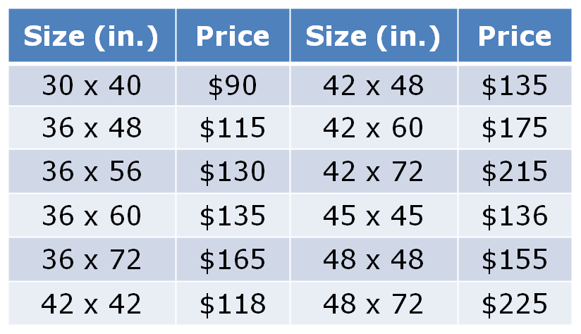

or you can use makesigns.comhttp://www.makesigns.com/SciPosters_Templates.aspx

(full-color, glossy paper)

|  |  |
| --- | --- |
| 24" x 36 | **$21.79** |
| 36" x 48" | **$45.94** |
| 36" x 72" | **$62.04** |
| 42" x 56" | **$60.89** |

"

# 

# What about Authorship? What are Rush’s policies or guidelines on this…

Guidelines for Authorship on Scientific and Scholarly Publications Draft Policy Review Guide for Authorship Disputes

By *Stephanie C. Guzik, MBA, BSN, RN, CHRC Director, Research Compliance Research Integrity Officer*

*February 9, 2016*

**Criteria for Authorship**

•Authorship credit should be based on:

1. Substantial contributions to conception and design, or acquisition of data, or analysis and interpretation of data;

2. Drafting the article or revising it critically for important intellectual content, *and*

3. Final approval of the version to be published

**Authors should meet conditions 1, 2, and 3**

All individuals who qualify for authorship should be listed (right to refuse)

•Ability to take public responsibility for the appropriate portions of the content

•Multi-center projects should identify the individuals who accept direct responsibility for the manuscript

–Identify all individuals and group name

**Author Types**

* *Lead Author-* Assumes overall responsibility, including managerial and corresponding author

*a. Establish co-authorship (criteria)*

*b. Proper approval of manuscript from contributors, coordinating journal requirements*

*c. Ensure integrity of the work (*e.g., *complete, accurate data)*

* *Co-Author-*

*a. Provide consent for authorship (criteria), able to demonstrate responsibility for content*

*b. Consent for authorship documents (to the lead) review and approval of the manuscript*

*c. Ensure integrity of the work, responsible for content and appropriate portions of the manuscript*

# 

# Additional Forms

Memo for Faculty to Donate Monies to Fund Research

To:

Carolyn Roche,

Development Associate,

Corporate and Foundation Relations

Office of Philanthropy

Natalie Landfair,

CHS Financial Manager

Christy Tangney, Ph.D., CNS, FACN,

CHS Associate Dean for Research

Date:________________

I __________________________________________________ wish to

Faculty Name

donate $________ to the CHS Departmental Fund1. I understand

(amount)

Natalie will track how these monies are used towards my research effort.

Sincerely,

______________________________ ______________________

Signature; Print name

1Please attach a copy of the letter received from the sponsor with this signed letter.

|  |  |  |  |  |  |
| --- | --- | --- | --- | --- | --- |
| Independent Contractor Invoice Template | | | | | |
| **Submit payment to:**  **Company/Contractor Name** | | INVOICE | | | |
| Address: | | DATE: | |  | |
|  | |  | |  | |
| Phone: | |  | |  | |
|  | |  | |  | |
|  | |  | |  | |
|  | |  | |  | |
| BILL TO | |  | |  | |
|  | |  | |  | |
| Rush University College of Health Sciences | |  | |  | |
| 600 S. Paulina St., Armour Academic Center | |  | |  | |
| Chicago, IL 60612 | |  | |  | |
| 312-942-7206 | |  | |  | |
|  | |  | |  | |
|  | | | QTY | | AMOUNT |
|  | | |  | |  |
|  | | |  | |  |
|  | | |  | |  |
|  | | |  | |  |
|  | | |  | |  |
|  | | |  | |  |
|  | | |  | |  |
|  | | |  | |  |
|  | | |  | |  |
|  | | |  | |  |
|  | | |  | |  |
|  | [42] | | Subtotal | | $ |
|  | | TOTAL Due | | $ |
| OTHER COMMENTS |  | |
|  |  | |
|  |  | |
|  |  | |

## Internal Request to Use UIC – CCTS Services

Our College has limited resources and we wish to use these as equitably as possible to support growth in our research programs! This form will be placed in the Research Handbook (also available on our portal <https://ruconnected.learn.rush.edu/colleges/CHS/Pages/default.aspx> under **Faculty Documents** Tab on the right… the very first Category (it’s unnamed)

Please answer the questions below and send to Christy Tangney for approval **before you submit to UIC CCTS group…**.

1. Name
2. Department
3. Is this request for
   1. Journal article publication*
   2. Grant Submission
   3. Masters Thesis Project for which you are the advisor
      1. If the latter, will this result in a peer-reviewed journal publication*?
         1. Yes
         2. No
   4. Other ______________________________
4. Anticipated level of statistical need
   1. To confirm stats were appropriate for publication?
      1. Yes
      2. No
   2. A full detailed analyses will be requested
      1. Yes
      2. No
   3. Other______________________________
5. Funding source (grant vs CHS dollars; please share a copy of the budget with this)
   1. Seed grant
      1. Yes
      2. No
   2. Other Internal Grant (Name) ________
   3. External Funding (Name) ________
   4. External/internal funding is not available
6. Brief description of what activities will be performed by statistician (can be bullets)
7. Brief description of how the research fits into a faculty research program:

* The expectation is that these papers will be sent to Dr Tangney to create a data depository for our College (ultimately to be housed by our Library)

X

Christy Tangney, PhD, FACN, CNS

Associate Dean for Research, College of Health Sciences

Rush University Medical Center