Office of Research Affairs
1653 W. Congress Parkway
Jelke Building, 601
Chicago, IL 60612
Tel: 312-942-3554
Fax: 312-563-2734
Jennifer_L_Garcia@rush.edu
www.rush.edu
Jennifer L. Garcia, CRA
Director, Sponsored Programs Administration

Rush University Medical Center

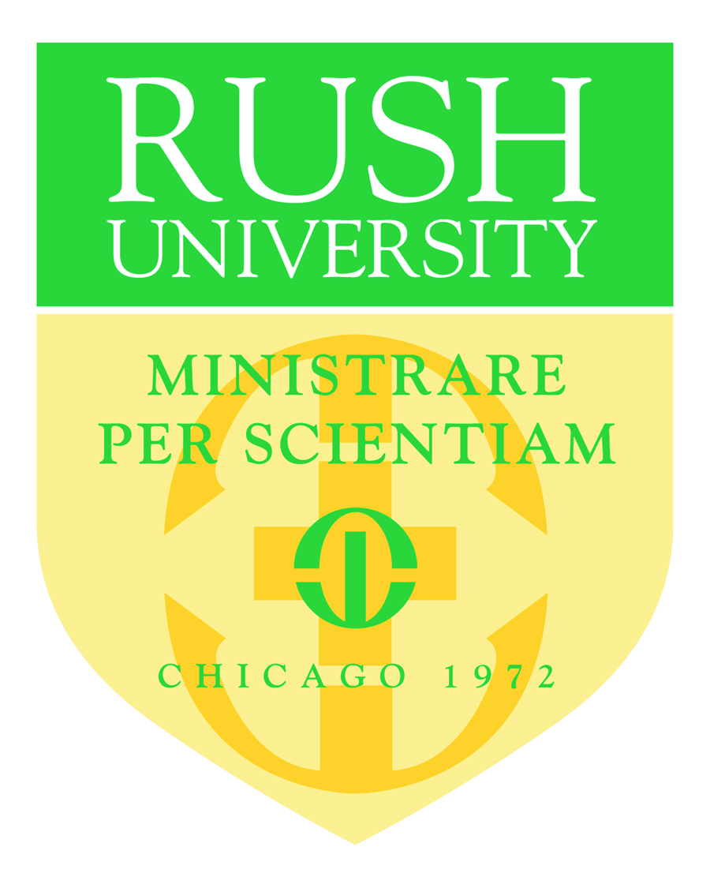

Statement of Intent to Establish a Consortium Agreement

XXXXX, Principal Investigator
Rush University Medical Center

Date: XXXXX

Application Title: XXXXX

Applicant Organization: XXXXX

Principal Investigator: XXXXX

The appropriate programmatic and administrative personnel of Rush University Medical Center involved in this grant application are aware of the National Institutes of Health consortium grant policy and are prepared to establish the necessary inter-institutional agreement(s) consistent with that policy.

RUMC has an active and enforced Conflict of Interest policy that is consistent with the provision of 42 CFR Part 50, Subpart F “Responsibility of Applicants for Promoting Objectivity in Research” and 45 CFR Part 94 “Responsible Prospective Contractors.”

DHHS Agreement dated: 4/13/2020
F&A Rate: 57% MTDC
Fringe Benefit Rate: 20.9%
Contact: Matthew Dito, Phone No. 214-767-3261
Duns No.: 06-861-0245
Congressional District: IL-007

Very truly yours,

Jennifer L. Garcia, CRA
Director, Sponsored Programs Administration

