Office of Research Affairs
1653 W. Congress Parkway
Jelke Building, Sixth Floor Chicago, IL 60612
Tel: 312-942-3554
Fax: 312-942-2874
www.rush.edu
Jennifer_Garcia@rush.edu
Jennifer L. Garcia, CRA
Director
Sponsored Programs Administration
Rush University Medical Center

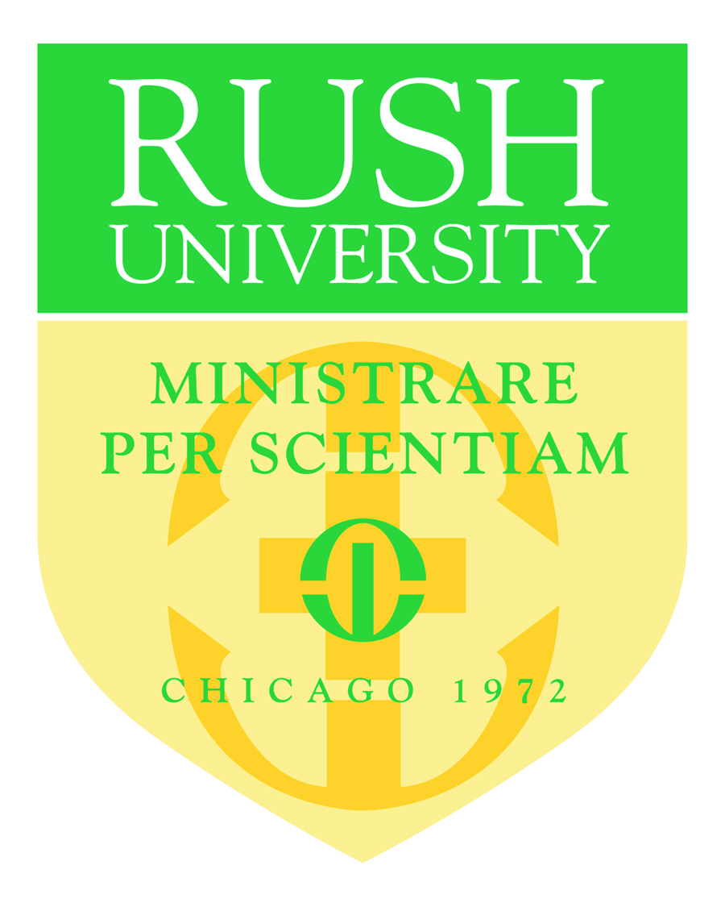

Statement of Intent to Establish a Consortium Agreement
XX, Principal Investigator
Rush University Medical Center

Date: XX

Application Title: XX

Applicant Organization: XX

Principal Investigator: XX

The appropriate programmatic and administrative personnel of Rush University Medical Center (RUMC) involved in this grant application are aware of the National Institutes of Health consortium grant policy and are prepared to establish the necessary inter-institutional agreement(s) consistent with that policy.
RUMC has an active and enforced Conflict of Interest policy that is consistent with the provision of 42 CFR Part 50, Subpart F “Responsibility of Applicants for Promoting Objectivity in Research” and 45 CFR Part 94 “Responsible Prospective Contractors.”
DHHS Agreement dated: 06/30/2017
F&A Rate: 57% MTDC
Fringe Benefit Rate: 19.7%
Contact: Uyen Tran, Phone No. 214-767-3261
Duns No.: 06-861-0245
Congressional District: IL-007

Very truly yours,

Jennifer L. Garcia
Director, Sponsored Programs Administration

