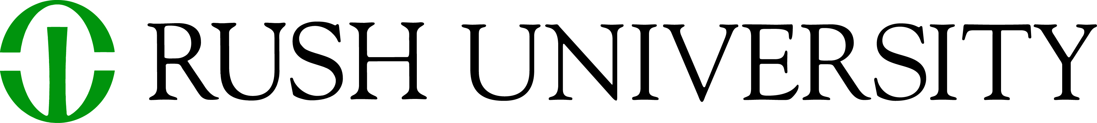

COSFAP DOSSIER ATTESTATION FORM

I, _______________________________ hereby confirm that my dossier is an accurate and comprehensive representation of my work. I attest that the above statement is true and valid to the best of my knowledge.

Signature of candidate Date

